REVISION F



Prepare and Manage NASA SMA Requirements Documentation

/s/ June 5, 2008
Bryan O’Connor Date
Chief, Safety and Mission Assurance

Approved for public release; distribution is unlimited.

DOCUMENT HISTORY LOG

Status (Draft/ Baseline/ Revision/ Canceled) | Document Revision | Effective Date | Description
Baseline |  | January 13, 2000
Revision | A | April 14, 2000 | Modified Section 5 Flowchart outputs from steps 6.05, 6.07, & 6.10 and modified steps 6.12, and 6.16; Editorial corrections to steps 6.03, 6.04, 6.06, 6.07, 6.09, 6.10, and 6.12 – 6.17; Added second Quality Record to Section 7
 | B | February 2, 2002 | Added customer list, customer feedback to sections 5, 6.09, 6.12, and 6.14. Editorial corrections to sections 1, 3.10, and 4.3. Updated procedures for adoption of standards in sections 6.01, 6.02, 6.06, 6.08, 6.09, 6.13, 6.14, and 6.17. Removed HATS action item tracking from sections 6.05, 6.13, and 7. Changed retention of Discipline Review Draft and OSMA Approved Document in section 7. Due to the cancellation of HOWI 1410-Q003, the following changes were made: Section 3.13, flowchart step 6.05, steps 6.05, 6.08, 6.13, and 6.17.
 | C | October 31, 2003 | Added definitions. Modified process steps 6.03 through 6.07, 6.09, 6.10, 6.13, 6.16, and Appendix A to reflect changes in OSMA organization and new NODIS and NASA Standards processing.
 | D | March 31, 2004 | Editorial and organizational changes to all sections.
 | E | December 3, 2004 | Modified scope to address new content and format specifications. Added definitions. Modified process to clarify and to require adherence to content and format specifications found in Appendix B. Added Appendix B - Content and Format Specifications for SMA Requirements Documents. Editorial changes throughout to accommodate NASA transformation.
 | F | June 5, 2008 | Document renumbered. Revised process to simplify and consolidate different types of document reviews into a single process. Includes Union, OSHA, and NASA-HDBK development reviews. Added Appendices C, D, E, and F.

HOWI Author: John W. Lyver, IV, C.S.P.
OSMA Staff Member Responsible for this HOWI: Michael Stamatelatos, Ph.D.

Customers for this HOWI: Internal: HQ Offices, OSMA document developers/POCs, and NASA Technical Standards Working Group
External: none
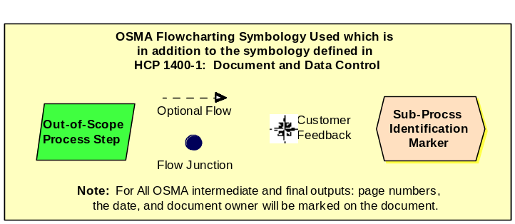

Purpose
The purpose of this Office of Safety and Mission Assurance (OSMA) Headquarters Office Work Instruction (HOWI) is to document the process for the initiation, development, and maintenance of NASA Safety and Mission Assurance (SMA) requirements documents. This OSMA HOWI addresses the processing of:
- OSMA-developed: NASA Interim Directives (NID), NASA Policy Directives (NPDs), NASA Procedural Requirements (NPRs), NASA Standards (NASA-STD), and NASA Handbooks (NASA-HDBK)
- Other SMA-sponsored standards that are adopted (aka: Voluntary Consensus Standards)
- NASA-STDs and NASA-HDBKs that the OSMA is requested to review.
This OSMA HOWI also specifies the retention requirements for Quality Records associated with the process (paragraph 6) and supplemental information for document retention (Appendix A).

Scope and Applicability
2.1 This OSMA HOWI is applicable to the propagation of SMA requirements documents by the OSMA organization. (See paragraph 3 definitions for SMA requirements documents for a description of the types of documents considered to be SMA requirements documents for the purposes of this OSMA HOWI.)
Note: The propagation of OSMA HQOWIs is covered by HOWI 1410-GD01.
Note: This process interfaces with a more global process owned by the HQ Office of Internal Controls and Management Systems (ICMS) as defined in NPD 1400.1 and NPR 1400.1.
2.2 The requirements delineated in Appendix B are applicable to all SMA requirements documents.

Definitions

CDM: Comment Disposition Matrix

Chief/SMA: Chief, Safety and Mission Assurance.

DD: Division Director.

DL: Document Lead.

DM: OSMA Documentation Manager. (aka: SMA Technical Authority Requirements Manager)

HATS: Headquarters Action Tracking System.

ICMS: Office of Internal Controls and Management Systems

NASA Handbook (NASA-HDBK): NASA-HDBKs are documents written to supplement NPD/NPR/NASA-STD documents. NASA-HDBKs use the same format as NASA-STDs, but they DO NOT contain any requirements. NASA-HDBKs are nominally signed by the Chief/SMA. Within NASA the broad term “Handbook” may include the following specific document types: Codes, Guidebooks, Handbooks, Specifications, and Technical Reports (refer to NPD 8070.6, Technical Standards and the “Guidelines for Preparing NASA Technical Standards (Handbooks, etc.) as tailored from MIL-STD-962C”).
(See Appendix D for guidance for the selection of the appropriate documentation type – NPD/NPR/NASA-STD/NASA-HDBK/...)

NASA Policy Directive (NPD): NPDs are policy statements that describe "what" is required by NASA management to achieve NASA's vision and mission. An NPD may relate to one or more subordinate NPRs that describe associated procedural requirements. NPDs apply to all NASA Centers and Component Facilities. The Administrator signs all NPDs (refer to NPR 1400.1).

NASA Procedural Requirements (NPR): NPRs provide mandatory procedures and requirements to implement NASA policy as delineated in an associated NPD (refer to NPR 1400.1). Nominally, NPRs contain those requirements which are performed by NASA.

NASA Standard (NASA-STD): NASA technical standards are NASA documents that contain common and repeated use of rules, conditions, guidelines, or characteristics for products or related processes and production methods, and related management systems practices. NASA technical standards may contain the definition of terms; classification of components; delineation of procedures; specification of dimensions, materials, performance, designs, or operations; measurement of quality and quantity in describing materials, processes, products, systems, services, or practices; test methods and sampling procedures; or descriptions of fit and measurements of size or strength.

NTSS: NASA Technical Standards System (http://Standards.NASA.GOV)

NTSWG: NASA Technical Standards Working Group

NHQ Form 184: NASA Directive Request Summary, filled out online in the NASA On-Line Directives Information System (NODIS) to initiate an Agency directive review.

NODIS: NASA On-line Directives Information System.

Objective Evidence: Any statement of fact, either quantitative or qualitative, pertaining to the quality of a product or service based on observations, measurements, or tests which can be verified. (Evidence is expressed in terms of specific quality requirements or characteristics. These characteristics are identified in drawings, specifications, and other documents which describe the item, process, or procedure.)

OSMA Management Council: OSMA’s management steering group comprised of the Deputy Chief/SMA, DD/Mission Support Division, DD/Safety and Assurance Requirements Division, Director, NASA Safety Center, and the OSMA Resources Manager.

Plans: NASA documents that present goals, objectives, and operational details to guide users in achieving NASA’s mission. NASA’s planning process starts with long-term Vision and Mission and flows to more focused near-term plans and documents.

PM: Program Manager.

RL: OSMA Resources Office Lead

SMA Documentation Status Tree (DocTree): A graphical representation of how the OSMA has assembled and interrelated its documents using a visual graphical interface. The DocTree may be used to both understand the document set for which OSMA is responsible and can be used for a hyperlink to meta-data about the document, the document status, the document itself, and training that may also be available. The DocTree is maintained by the DM with the OSMA Webmaster and is located at http://www.hq.nasa.gov/office/codeq/doctree/index.htm.

SMA Functional Leadership Plan: The SMA document that sets the overall direction, goals, objectives, and strategies for SMA within NASA. (NOTE: As of approval of this HOWI, the SMA FLP is not up to date.)

SMA Requirements Document: OSMA-developed NPDs, NPRs, NASA Standards, SMA-sponsored standards that are adopted, and the SMA Functional Leadership Plan are considered SMA requirements documents for the purposes of this OSMA HOWI.

SMARTS: Safety and Mission Assurance Requirements Tracking System. (http://SMARTS.NASA.GOV)

SUNS: Standards Update Notification System

WM: OSMA Webmaster

Work Instructions: Work instructions are NASA documents that contain instructional requirements applied to an individual organization that define the processes used to deliver products to customers or to meet the organization’s mission requirements as defined by Directives. OSMA work instructions are developed in accordance with HOWI 1410-Q001.

Reference Documents
The documents listed in this section are used as reference materials for performing the processes covered by the Quality Management System (QMS). Since all NASA Headquarters Level 1 (QMS Manual) and Level 2 (Headquarters Common Processes) documents are applicable to the QMS, they need not be listed in this section unless specifically referenced in this OSMA HOWI.

NPR 1400.1: NASA Directives System Procedural Requirements.

NPR 1450.10, NASA Correspondence Management and Communications Standards and Styles.

NPD 8070.6: Technical Standards.

Guidelines for Preparing NASA Technical Standards (Handbooks, etc.) (Tailored from MIL-STD-962C, dated 31 July 2001) ( http://standards.nasa.gov/procsguidlns.pdf ).

The Gregg Reference Manual, Eighth Edition, 1998.

Presidential Memorandum of June 1, 1998, Plain Language in Government Writing (http://www.plainlanguage.gov/cites/memo.htm).

Flowchart
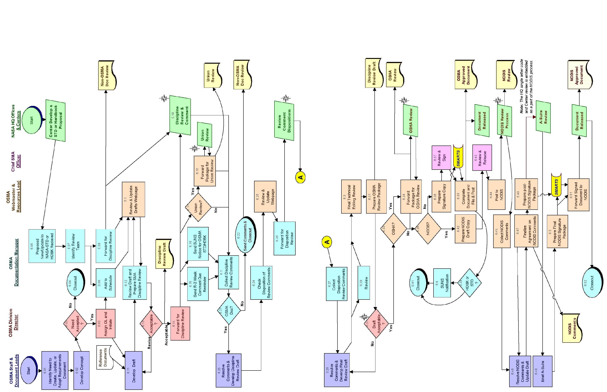

Procedure
  - OSMA Staff Member Identify Need to Create, Update, or Adopt Requirements Document:
The need to develop a new or update or adopt a current SMA requirements document may be identified through a number of means. Means of identifying a need include, but are not limited to: the identification of a gap in the requirements tree for OSMA, direction from the senior management, changes in regulations or laws of an external authority, the identified need by customers needing guidance, a deficiency identified by evaluation of request for variance (refer to HOWI 8700-Q004), functional reviews, compliance verifications, audits, or benchmarking efforts. The OSMA Documentation Manager (DM) can initiate the process for documents which are approaching expiration.
  - OSMA Staff Member Develop Concept:
The OSMA staff member identifies and details the documentation deficiency, establishes a plan for the SMA requirements document development, update, or adoption, and briefs the Division Director (DD) with responsibility in that area.
(NOTE: See OSMA website for OSMA Division responsibilities.)
  - DD Need Accepted?
The DD with responsibility for the document area reviews the concept developed in the previous step and decides whether the proposal is necessary. If the proposed change is not needed, the process is closed out.
  - DD / DM Closeout:
If the proposed change is not needed, the process is terminated.
NOTE: If the document is being allowed to expire, then a Cancellation Notice will be needed and the below process followed beginning with step 6.10.
  - DD Assign DL and Initiate:
a. The DD assigns a staff member to be responsible for and lead the document development/update, or adoption as the Document Lead (DL) of the change.
b. The DL notifies the DM of the change.
(Skip to steps 6.09 and 6.11)
  - DM Proposed New/Update to NASA-STD or NASA-HDBK Received:
The process in this HOWI is initiated when DM receives a notification of a proposed update or proposed new NASA-STD or NASA-HDBK which is not an OSMA document. This notification will normally come from the NTSS Manager or the NASA HQ Office developing the document.
  - DM Identify Review Team:
The DM reviews the change and identifies the list of personnel (and NASA SMA organizations) that should have an interest in the document.
  - DM Forward for Discipline Review:
The DM forwards the proposal reviewed in step 6.06 to the review team. The format and sample distribution list in Appendix C is used as a template and the proposal is e-mailed to the review team and the OSMA Webmaster (WM). Comments are requested to be returned to the DM usually within a calendar week prior to the due date provided with the document.
(Skip to step 6.10)
  - DM Add to Schedule:
The DM redlines the documentation review/publishing schedule and provides the updates to the WM for posting.
  - DM Review Draft and Prepare SMA Discipline Review:
a. The DM, working with the DL, prepares the package to send out the draft for review. The review is normally sent to SMA Directors/Offices throughout NASA, Mission Directorates, HQ Offices involved with the document, the NASA Technical Standards Working Group (NTSWG) members, and associated Subject Matter Experts. Examples for the letter are contained in Appendix C to this HOWI.
b. The DM provides the DD the draft document and a letter requesting review to the DD/Safety and Assurance Requirements Division and the WM to initiate the discipline review.
c. Comments are nominally asked to be returned to the DM in about 30 calendar days. For NIDs, comments are usually given 2-3 weeks to review.
d. The draft documentation package is forwarded electronically to the WM for posting.
(Both steps 6.12 and 6.13 must occur after this step)
  - DD, DL Develop Draft:
a. The DL, with advice from the DD and support of the DM, develops the draft change/document or proposal for adoption of a standard in accordance with references in Section 4 and the requirements in Appendix B of this OSMA HOWI.
b. The DL provides the DM with the draft document (or proposed standard for adoption) and a list of subject matter experts as reviewers (names and e-mail addresses) in an electronic format.
  - RL & WM Review and Update Drafts Webpage
a. The OSMA Resources Lead (RL) reviews the draft for completeness. If issues, grammatical errors or other corrections are found, then the document is returned to the DM and DL to resolve before proceeding.
b. If this is a new OSMA document, then an interim document number is assigned by the DM.
c. The WM ensures that the new/revised document is added to or updated on the SMA Documentation Drafts Webpage, and updates the SMA Documentation Schedule.
d. The DM and the WM develop/update the OSMA Drafts Webpage.
Note: Appendix E provides information on the OSMA Drafts Webpage and the associated Document Metadata.
  - DD Acceptable?
The DD decides whether the document is mature enough to send out for discipline review or return to the DL and DM to update.
  - DD Forward for Discipline Review
The DD makes the final determination of who should review the draft during the discipline review from the list of names sent by the DM. At a minimum, Mission Directorates, various HQ Offices (NASA General Counsel, Office of External Relations, Office of Chief Engineer, and Office of Chief Health and Medical Officer), each Center SMA Director, OSMA DDs, NTSWG Members, and associated subject matter experts in the document field(s) are included in the discipline review. Other reviewers may be added internal and external to NASA based on the subject and interfaces affected. The distribution list is described in Appendix C. Normally, the discipline review participants are given 30 calendar days to provide OSMA with comments. For NID reviews, comments are due in 2-3 weeks.
NOTE: Consolidating various documents into a single discipline review request may help the process.
NOTE: The designated NASA HQ Offices and Centers staff the initial draft document through their respective organization(s) and provide comments back to the DM.
  - DM Send out R-2 Week Comment Due Reminder
The DM forwards the note sent out in step 6.14 to all of the reviewers who received that note reminding/requesting that they provide their comments within 2 weeks so the document review can continue on schedule. Reviewers will be asked for “null” inputs if they do not plan on providing comments.
  - DM Send SUNS Notice for OSMA STD/HDBK?
For updates to an OSMA NASA-STD and NASA-HDBK, the DM logs on to the NASA Technical Standards System (NTSS) and issue a notice of the proposed update into SUNS for automatic distribution through the NTSS. A sample note is in Appendix C.
  - RL Union Review?
If the document is a NPD, NPR, or will involve a review by the Occupational Safety and Health Administration (OSHA), then the document is sent to the NASA Union for review.
  - RL Forward Package for Union Review:
The draft document package is sent to the NASA Union per NPR 1400.1. The NASA Union is entitled to 30 days to review the document. The response is returned to the RL and then forwarded to the DM for filing and comment incorporation/dispositioning.
  - Reviewers Discipline Review and Comment:
During this step, reviewers are asked to review the draft and provide comments back to the DM. A sample comment disposition matrix (CDM) is provided in Appendix C. Requests for extensions to the comment due date must be sent to the DM for coordination/approval.
  - DM Collect Discipline Review Comments:
The DM collects all of the comments from the Reviews and provides them in a CDM to the DL to disposition the comments and update the draft. (If the document being reviewed is NOT an OSMA document, skip to step 6.24.)
  - DM OSMA Doc?
If the document being reviewed is not an OSMA-controlled document (entered the process at step 6.06) then either the final step in the process (Step 6.24) is used, or if it is an OSMA-controlled document then the process continues with step 6.25.
  - DM & WM Send Comments and Closeout
The DM sends the CDM to the originator, files the comments and a copy of the submitted draft, and closes out the process.
  - DL Resolve Comments and Develop the Discipline Review Draft:
a. The DL develops a response for each comment received and records the dispositions on the CDM.
b. The DL revises draft based on comments and updates the CDM that includes all of the comments received on the document and their disposition. Nominally, the DL should complete the comment disposition no later than 30 calendar days from the end of the review.
c. The DL reviews the revised draft, along with the CDM, with the DD for a decision to proceed with further processing. The process then can proceed to step 6.24 recycle to step 6.11, or be closed out.
d. The DL forwards the updated draft and the CDM to the DM and RL.
  - DM & RL Review Disposition of Review Comments
a. The DM and RL review the CDM to ensure that all comments are dispositioned and that the dispositions are (1) appropriate/clear/complete, and (2) answer the original question/comment. The CDM is updated. If problems are found, the DM & RL will work with the DL to update the draft and the CDM.
b. The DM forwards the CDM and updated Draft to the WB and the RL.
  - RL & WB Review and Update Webpage
a. The RL reviews the document for format, completeness, style, grammar, conformance to NPR 1400.1, NPD 8070.6, this HOWI, as well as other OSMA documentation practices.
b. The WM uploads the CDM and draft to the OSMA drafts website and updates the documentation schedule.
  - DM Forward for Disposition Review
The DM updates the memo sent out in step 6.14 and sends an e-mail to the NASA SMA Offices and anyone who provided comments during the review in step 6.19. The reviewers will be asked to verify the dispositions of their comments and send back any comments and concurrence on the dispositions or the updated draft. Comments will nominally be asked to be returned to the DM within 10 days. The updated draft and completed CDM are found on the OSMA Drafts Website.
  - DM Collect Disposition Review Comments
The DL collects all of the comments from the Disposition Review and provides an updated CDM to the DL for dispositioning any new comments and further updating the draft.
  - DL Resolve Comments and Develop the Discipline Final Draft:
a. The DL develops a response for each comment received and records the disposition on the CDM.
b. The DL revises draft based on comments and updates the CDM that includes all of the comments received on the document and their disposition. Nominally, the DL should complete the comment disposition no later than 10 calendar days from the end of the review.
c. The DL reviews the revised draft, along with the CDM, with the DD for a decision to proceed with further processing.
d. The DL forwards the updated draft and the CDM to the DM and RL.
  - DM Review:
The DM reviews the Final draft and provides comments to the DL and the RL for incorporation in the OSMA Review Package version of the draft.
  - RL Final Technical Editing Review:
The RL reviews the document again to ensure that it meets the requirements and style specified in NPR 1400.1, NPD 8070.6, and this HOWI.
  - RL Prepare OSMA Review Package:
The OSMA Review package contains the draft document, the CDM, and any other review materials. The package is forwarded to the DD responsible for the document.
  - DD Draft Acceptable?
The DD reviews the signature package and initials the review slip as acceptable and returns to the RL or indicates that more work is needed prior to proceeding and returns the package to the DL.
  - RL OSHA?
If the document is an OSHA Supplemental Standard or OSHA Alternate Standard, then Step 6.34 is used. Otherwise, proceed to step 6.35.
  - RL Forward Package for OSHA Review:
- The OSMA review package is forwarded to OSHA for their review. Nominally a cover letter would accompany the package from the Chief, Health/Medical, as the Designated Agency Safety and Health Official (DASHO) requesting their review. Justification/analysis for the change will need to be included with the request.
- The request for review and any comments are sent to the WM for updating the draft website.
  - RL NODIS?
The RL reviews the draft to determine if the document is defined as a directive (reference 4.1) and requires additional processing through the NODIS process or if it can be processed directly for signature.
If the draft is to be processed through the NODIS review process, the RL provides the schedule to the DL and the DM. If the draft is an NPD or NPR (or other special document controlled by the NODIS), then steps 6.42 and beyond are used. Otherwise proceed to step 6.36.
  - RL Prepare Signature Copy:
a. The signature package is forwarded to the OSMA HATS manager (See HOWI 1450-GB27), DDs, Deputy Chief/SMA, and Chief/SMA for signature.
b. The RL/DM forward the signature draft document to the SMA Requirements Tracking System (SMARTS) Contractor for parsing and loading into SMARTS. When the SMARTS requirement identification tags are determined, then the document is updated to contain these requirement numbers/tags.
  - Chief/SMA Review and Sign
The Chief/SMA signs the document and returns it to the RL.
  - RL, WM, & DM Complete Document, File & Post
a. The RL completes the signature process by having the HATS system updated to record the signature. A copy is placed in the Chief/SMA chron file and the signature package is forwarded to the DM for filing.
b. The DM updates the draft with the actual signature dates and provides to the WM for uploading.
c. The WB posts the new document on the OSMA Document Tree and updates the Drafts Webpage to indicate that the document has been signed. The Documentation schedule is updated.
  - DM HDBK or STD?
If the document is a NASA-STD or a NASA-HDBK, proceed to step 6.40, otherwise go the step 6.41.
  - DM SUNS Notification:
The DM provides the update information to the NTSS/SUNS system that the new document has been issued. The DM also provides the new weblink to the NTSS Admin staff for updating of NTSS.
  - DM Closeout:
After filing the signature package, updating the master documentation schedule, and ensuring that the OSMA DocTree and Drafts webpages have been updated, the process is closed out.
  - RL Prepare NODIS Draft Copy:
a. The RL with the DL (and DM oversight) prepare the concurrence package for release to NODIS. The concurrence package contains the draft, the disposition matrix, and the completed NHQ Form 184.
b. The RL routes the package to all OSMA DDs, the Deputy Chief/SMA, and the Chief/SMA for concurrence.
  - Chief/SMA Review and Release:
The Chief/SMA signs the route slip for submission of the document to NODIS for further reviews.
  - RL Post to NODIS
a. The RL uploads the NODIS package materials to NODIS. The RL provides the document for release into the NODIS process in accordance with NODIS operating procedures and NPR 1400.1.
b. The RL sends to the WM.
c. The WM posts the NODIS draft and the form 184 to the OSMA Draft webpage.
NOTE: HQ Office of Internal Controls and Management Systems coordinates formal staffing of the document in accordance with NODIS procedures and recordkeeping requirements and releases and posts the signed directive to NODIS with a final document number after approval. (Internal Customer Feedback).
NOTE: The process of the NODIS review nominally begins with the second Tuesday of the month. The current schedule for NODIS reviews can be found at: http://nodis-dms.gsfc.nasa.gov/dms/Review_Cycle_Report.cfm
  - RL Collect NODIS Comments:
The RL checks the status of the NODIS review periodically. Near the end of the review, the RL prepares a CDM and places it on the OSMA U: Drive in the appropriate Directives Coordination File. The DL can begin dispositioning of all received comments and updating of the draft document as soon as they are received. The RL will continue to update the CDM until all offices required to provide review comment/concurrence have entered their comments/concurrences into NODIS.
  - DL Resolve NODIS Comments and Update DRAFT:
a. The DL develops a response for each comment received and records the dispositions on the CDM
b. The DL revises draft based on comments and updates the CDM that includes all of the comments received on the document and their disposition.
c. The DL reviews the revised draft, along with the CDM, with the DD for a decision to proceed with further processing.
d. The DL forwards the updated draft and the CDM to the DM and RL. The DL follows the schedule provided by the RL in step 6.35.
  - RL (with the DM) Finalize Agreement on NODIS Comments:
a. If the review cannot be completed in the allotted time per the NODIS process, then the RL prepares a memo from the Chief/SMA to request an extension to the NODIS review time.
b. If the RL, DM, DD, DL feel that the document comments cannot be resolved by the end of the extension period with ALL NODIS reviewers concurring with the document, then the RL withdraws the draft from NODIS and the process either recycles back to step 6.42 or the draft is cancelled outright and process is closed.
c. As the DL reaches a disposition on each NODIS reviewers’ comments, then the RL posts the dispositions to NODIS for the NODIS reviewer to concur with the disposition. This is especially important where OSMA has disagreed with a comment or a reviewer has not yet concurred with the draft as a conclusion of their review.
Note: This step will iterate until all reviewers and OSMA are in agreement with the dispositions and the updated draft.
  - RL Prepare post-NODIS Signature Package:
a. Once all concurrences have been received, the RL prepares a signature “purple package.”
b. The RL and the DM forward the signature draft document to the SMA Requirements Tracking System (SMARTS) Contractor for parsing and loading into SMARTS. When the SMARTS requirement identification tags are determined, then the document is updated to contain these requirement numbers/tags.
c. The signature package is then routed to the NODIS Administrator for continued review/processing through the Office of the Administrator.
  - DL Brief A-Suite:
If the Office of the Administrator requests a briefing for a change to a document, the DL will present in 15 minutes (or so) what the change was. This is not always required. The briefing is provided to the RL, DM, and WM for saving and uploading as a Quality record. Appendix C contains a sample presentation.
  - RL Prepare Approval NODIS Signature Package:
a. After the “Purple Package” sent to NODIS in step 6.48 returns to OSMA, the RL works with the DL and DM to make any final changes to the document. If SMARTS Requirements IDs have been generated, then they are added to the document.
b. If the package requires the signature of the Chief/SMA, the RL obtains the signature.
  - RL Forward Final Signed Document to NODIS:
a. The RL returns the ‘purple package” to NODIS Administrator for loading into NODIS and forwards the final document to NODIS and records retention.
b. The RL notifies the DM and WB to update the OSMA Doc Tree and Drafts Webpage.
  - DM Closeout:
After verifying that all the parts in step 6.52 have been completed, the DM files the records and closes out the process.

Quality Records
Record ID | Owner | Location | Media Electronic /hardcopy | Schedule Number & Item Number | Retention & Disposition
Non-OSMA Doc Review | DM | DM Files | Hardcopy | Schedule: 1  Item: 72.D | Keep until document topic is withdrawn then destroy
Discipline Review Draft | DM | DM Files | Hardcopy | Schedule: 1  Item: 72.C | Keep until new document is approved and all review issues are resolved then destroy
Union Review | DM | DM Files | Hardcopy | Schedule: 1  Item: 72.D | Keep until document is withdrawn from OSMA Control then destroy
NODIS Review | DM | DM Files | Hardcopy | Schedule: 1  Item: 72.D | Keep until document is withdrawn from OSMA control then destroy
NODIS Approved Document  **Not an OSMA Quality Record** | Office of Internal; Controls and Management Systems | NODIS | Hardcopy/ Electronic | Per NPR 1400.1 | Per NPR 1400.1
OSHA Review | DM | DM Files | Hardcopy | Schedule: 1  Item: 72.D | Keep until document is withdrawn from OSMA control then destroy
OSMA Approved Document  (** Document is not in NODIS **) | OSMA DTM | Safety and Assurance Requirements Division | Hardcopy | Schedule: 8  Item 12.A | * Permanent *  Retire to FRC when no longer needed for reference. Transfer to NARA when 15 years old.

Appendix A: Supplemental Optional Information on Documentation Retention:
- For NASA Directives: Copy of the initial staffing package and disposition matrix in both electronic and hard copy. Copy of the signature-ready master document provided to Office of Internal Controls and Management Systems for release in electronic copy (hardcopy may also be retained) and the NODIS Forms 184 and 117.
- For SMA Functional Leadership or Strategic Plan: A Master hard copy of the Plan with original signature, electronic copy of the master document, and hard copy and/or electronic copy of the disposition matrix.
- For NASA-STDs: Master NASA-STD – hard copy with original signature, electronic copy of the master document, and hard copy and/or electronic copy of disposition matrix.
- For adopted standards – a hard copy of the adoption notice with the original signature and electronic copy of the disposition matrix.
For all documents: the old document and Chief/SMA signature packages are kept.
Appendix B: Content and Format Specifications for SMA Requirements Documents

All DLs shall adhere to the format and content requirements described in this Appendix when writing SMA requirements documents.

B.1 Document Type. Use the definitions in Section 3 of this OSMA HOWI to determine what type of requirements document you need to write. If you are not sure what type is appropriate for your SMA requirements document, consult the OSMA DM.

B.2 Distribution Statement. Place on the cover sheet one of the two statements below to describe the distribution of the SMA requirements document. The distribution is determined by the DL, based on knowledge of the subject matter and any feedback from the Office of the General Counsel and the Office of External Relations.

B.2.1 Approved for public release; distribution is unlimited.

B.2.2 Approved for release to U.S. Government employees and their contractors; distribution is limited.

B.3 Authority Statement. Designate the higher level authority(ies)/requirement(s) that justifies establishing the SMA requirements document.

B.3.1 For NPDs, the higher level authority may be an external document such as Public Law or it may be a higher level NPD.

B.3.2 For NPRs, the higher level authority shall be an NPD.

B.3.3 For all other SMA requirements documents, the higher level authority may be either an NPD or an NPR.

B.4 References and Applicable Documents

B.4.1 For NPDs and NPRs, only list documents as applicable documents if they are cited within the text of the document. If you wish to include a list of suggested or related reading, include it as an appendix.

B.4.2 When citing NPDs or NPRs as applicable documents and references, record the citation without the revision letter. NPDs and NPRs become effective upon signature and only the current revision is effective.

B.4.3 Make sure that all applicable documents and references cited are current and correct. The only draft documents that may be cited as references are draft NPDs or NPRs that have formally been entered into NODIS review and are accessible in the NODIS drafts website.

B.4.4 Use footnotes (or URLs) to show readers precisely where to find applicable documents and references that are not readily available to all users in NODIS or the NTSS.

B.5 Requirements Statements

B.5.1 General.

B.5.1.1 For each requirements statement, specify who must take the action and what action must be taken.

B.5.1.2 Make sure that at least one person or organization is designated as responsible and accountable for completion of the requirement.

B.5.1.3 All requirements shall have associated objective evidence for compliance statements.

B.5.2 Clearly distinguish between requirements and nonrequirements. (A requirement is a single action that is to be performed.)

B.5.2.1 Use the correct phrasing.

B.5.2.1.1 For requirements, use the word “shall.”

B.5.2.1.2 The word “may” shall only be used if the requirement is granting permission to perform an action.

B.5.2.1.3 It is prohibited to use the word “should” or the word “will” to denote a requirement.

B.5.2.2 The following definitions apply:

B.5.2.2.1 Shall – "Shall" means the imperative. Action is mandatory.

B.5.2.2.2 May –"May" denotes the permissive; confers a discretionary privilege. Action is optional. However, the words "no person may ..." mean that no person is required, authorized, or permitted to do the act described.

B.5.2.2.3 Should - "Should" means an expected course of action or policy that is to be followed unless inappropriate for a particular circumstance. Action is optional.

B.5.2.2.4 Will – - “Will” anticipates a future action. Action is optional.

B.5.2.3 In all SMA requirements documents, place the word “Requirement” in parenthesis after each requirement statement. Example: (Requirement).

B.5.3 Include only one requirement statement per paragraph.

B.5.4 Avoid caveat phrases (e.g., as applicable, as appropriate, whenever possible) within requirements statements.

B.6 Responsibility Statements

B.6.1 Designate responsibilities and procedural requirements for NASA organizations in NPDs and NPRs.

B.6.2 Except in extraordinary circumstances, assign responsibilities at a level that allows an organizational leader to organize or assign responsibilities within the leader’s organization.

B.7 Measurements Statements

B.7.1 Define measurements that shall be collected to support senior management evaluation of performance for compliance and implementation of the Agency’s policies.

B.7.2 For all measurement statements, indicate:

B.7.2.1 What data must be collected

B.7.2.2 Who is responsible for collecting and reporting the data

B.7.2.3 To whom the data is delivered

B.7.2.4 How often the data is reported/delivered.

B.7.3 Identify measurement data that responds to requirements levied external to the Agency to provide traceability to those requirements, for example, Government Performance and Results Act reporting requirements.

B.8 Verification

B.8.1 Make sure that all requirements are verifiable with objective evidence of compliance (per the requirements of NPR 8705.6).

B.9 Writing Style

B.9.1 Use gender-neutral language.

B.9.2 Use plain language as directed in the President's Memorandum for the Heads of Executive Departments and Agencies, dated June 1, 1998, Subject: Plain Language in Government Writing.

B.9.3 Use NPR 1450.10 and The Gregg Reference Manual as style references.

B.9.4 Adhere to the following style rules when writing SMA requirements documents:

B.9.4.1 Limit sentences to one thought.

B.9.4.2 Use parallel construction (the same grammatical structure for similar or related ideas).

B.9.4.3 Write in the active voice (name an actor with the action immediately after) because it is more direct and forceful; e.g., “The Chair shall forward one information copy of the board meeting minutes to the members.”

B.9.4.4 Spell out an acronym or abbreviation the first time it appears, followed by the acronym or abbreviation in parentheses. If an acronym or abbreviation appears only twice or infrequently, spell out the term every time and avoid the acronym entirely.

B.9.4.5 Limit paragraphs to a few lines and a few sentences.

B.9.4.6 Number every paragraph so that it may be referenced.

B.10 Basic Rules for Writing NPDs and NPRs

B.10.1 When there is a companion NPR or publication being processed during the same time as an NPD, the NPD shall be signed first. Hold the NPR or other publication until after the NPD has been signed to assure contents of the NPR are consistent with the related NPD.

B.10.2 Limit procedures documented in NPRs to procedural direction for essential or otherwise mandated items only. This includes procedural requirements that must be specified for reasons of safety, security, efficiency, and cost effectiveness.

B.10.3 Use standard placement for common Appendices in NASA NPRs.

B.10.3.1 Use Appendix A for the Definitions Appendix.

B.10.3.1.1 List definitions in alphabetical order.

B.10.3.1.2 Specify definitions only for terms used in the NPR and only if the definitions are uniquely different than used in dictionaries or other standard usage.

B.10.3.2 Place the Acronym Appendix no later than Appendix B.

B.10.3.3 If you need to document an organizational charter for a group lower than councils, boards, committees, and panels specified within NPD 1000.3 (for example, working group charters), you may use an appendix within an NPR.

B.10.4 Use the following applicability statement for all OSMA NPDs and NPRs: “This (NPD or NPR) is applicable to NASA Headquarters and NASA Centers, including Component Facilities.”

B.10.5 Adhere to the following prohibitions when writing NPDs and NPRs.

B.10.5.1 Do not put guidance (statements of expectation that do not mandate compliance) into NPDs or NPRs. NPDs and NPRs may include contextual information that supports the understanding of requirements.

B.10.5.2 Do not put technical requirements (a system or equipment must do something) in NPDs or NPRs. Technical requirements may be included in Technical Standards, which may then be cited in NPDs or NPRs.

B.10.5.3 Do not use bullets and dashes in NPDs or NPRs.

B.10.5.4 Do not use figures, forms, graphics, or tables in the text of an NPD.

B.10.5.5 Do not duplicate existing internal or external requirements within NPDs and NPRs.

Note: Cross-referencing may be used to cite existing requirements. NPDs and NPRs may supplement/clarify/make more stringent external requirements or designate who is responsible for implementation of external requirements but shall neither repeat nor lessen the requirement.

B.10.5.6 Do not include a responsibility to maintain the document within the document. The Responsible Office designation delineates this responsibility.

B.10.5.7 Do not include requirements in appendices of NPRs. Use appendices for supporting information for the core elements of the NPR.

B.10.5.8 Do not include requirements for contractors. SMA NPDs and NPRs are not intended to be applied directly on contracts.

Appendix C: Samples

Sample 1: Distribution List for Discipline Review for all Documents
NASA Headquarters Officials-in-Charge:
Associate Administrator for Aeronautics Research Mission Directorate/Dr. X
Associate Administrator for Exploration Systems Mission Directorate/Dr. X
Associate Administrator for Program Analysis and Evaluation/Dr. X
Associate Administrator for Science Mission Directorate/Dr. X
Associate Administrator for Space Operations Mission Directorate/Mr. X
Chief Engineer/Dr. X
Chief Health and Medical Officer/Dr. X
Office of Chief Information Officer/Mr. X
Office of External Relations/Mr. X & Mr. Y
NASA SMA Directors:
ARC/218-6/Mr. X
DFRC/2128/Mr. X
…
NASA Technical Standards Working Group:
Office of Chief Engineer/Mr. X
Office of Chief Information Officer/Mr. X
Office of Safety and Mission Assurance/Mr. X
ARC/Ms. X & Mr. Y
DFRC/Mr. X

Constellation Program SMA:
JSC/Mr. X/Y/Z

[Example is for Orbital Debris]
NASA Orbital Debris Working Group
Office of Safety and Mission Assurance/Mr. X/Y/Z
Science Mission Directorate/Ms. X
GSFC/Mr. Anderson, Mr. X, …

Sample 2: E-mail for request for review of non-OSMA NASA-STD or NASA-HDBK
Dear OSMA Staff, SMA Directors and SMA Professionals:
Draft NASA-STD <number>, <name>, is currently being reviewed for acceptance. A copy of the draft can be found on the OSMA Drafts Webpage at:
http://www.hq.nasa.gov/office/codeq/doctree/nasaonly/doctree_e.htm
After a brief review, I feel this document needs a full SMA community review beyond the normal NASA Technical Standards Working Group review. The Draft NASA-STD-<number> is nearly ready for signature and we are being given the chance for one last review before it is signed. Comments are due to the NASA Technical Standards Office at MSFC NO LATER THAN <date>.
You may provide comments EITHER direct to MSFC (by <day, date>) or you can send them to me (by <day, date> for inclusion with the OSMA comments. It is requested that the comment forms located on the OSMA Drafts Website be used for providing comments. Either way, here's our chance for SMA to be involved. If you have any questions or comments on this review, please give me a call.
Thank you!
v/r,
John

Sample 3: Memo for Request for Discipline Review for NPD and NPR
(Note: 1st paragraph is an explanation of the proposed change and the 2nd and 3rd paragraphs are standard)
TO: Distribution
FROM: Director, Safety and Assurance Requirements Division
SUBJECT: Draft Change to <name>
The Draft NASA Procedural Requirements Document (NPR 87x5.x) <name>, is ready for your review and comment prior to submission for formal approval. This change will <description>. Approval of this NPR will have impact across NASA.
This review is being processed with our updated process for requesting reviews using the new page to the OSMA Documentation Status Tree (aka: SMA DocTree) to consolidate the schedules, status, drafts, and results of updates/reviews of our documentation. The SMA Documentation Updates website is located at: http://www.hq.nasa.gov/office/codeq/doctree/nasaonly/doctree_e.htm.
and is limited to the NASA.GOV domain. Just click on the NPR 87x5.x document number hotlink to download the draft and a blank reviewer comment matrix for your use. After the review, we will disposition your comments and provide comments with feedback. A matrix of all of the review comments and their dispositions will be placed on the website before we submit this document for NODIS review.
We are asking for all comments to be sent to John Lyver of my staff and that all comments are received by COB <day and date>. If you have any questions on the draft or the new process, you can contact John at (202) 358-1155 or by e-mail at JLyver@NASA.GOV. If you have any technical questions on NASA’s <topic> program, you can contact <name> at (202) 358-<#> or by e-mail at <address> @NASA.GOV
Thank you for your assistance.
Best Regards,
s/Michael
Michael G. Stamatelatos

Sample 4: Memo for Request for Discipline Review for NASA-STD and NASA-Handbook
(Note: Only the 1st paragraph is shown. Paragraphs 2 and 3 are the same as those for NPRs as shown in the previous example)
TO: Distribution
FROM: Director, Safety and Assurance Requirements Division
SUBJECT: NASA Handbook 87x9.x, <name>
In accordance with NPD 8070.6, Technical Standards, OSMA is preparing to issue NASA-Handbook 87x9.x, <name>. The proposed change will <short description of change and/or reason for the new document>. This document has been developed by <office>. Use of this document is anticipated to be worldwide.
This review is being processed with …

Sample 5: SUNS Notification
You have an Update Notification for Document Number NASA-STD-8719.9. When the Standards Developing Organization provides information containing superseding or replacement documents, the superseding/replacement document number is automatically requested for you in the Standards Update Notification System. You will be notified when additional Update Notifications are received. The Document Update information is provided below.
Type of Change : | Revalidation (R)
Standard revalidated.
**********************************************************************
Current Revision
Document #: | NASA-STD-8719.9 (To locate this document, click http://standards.nasa.gov and access the Agency-wide Full-Text Technical Standards System.)
Revision: | Baseline
Title: | STANDARD FOR LIFTING DEVICES AND EQUIPMENT; Revalidated/Reaffirmed 10/01/2007
Release Date | 05/09/2002
Revalidated Date: | 10/01/2007
SDO: | NASA
Additional Comments:
**********************************************************************
Previous Revision
Document #: | NASA-STD-8719.9
Revision: | Baseline
SDO: | NASA
***********************************************************************

Sample 6: CDM
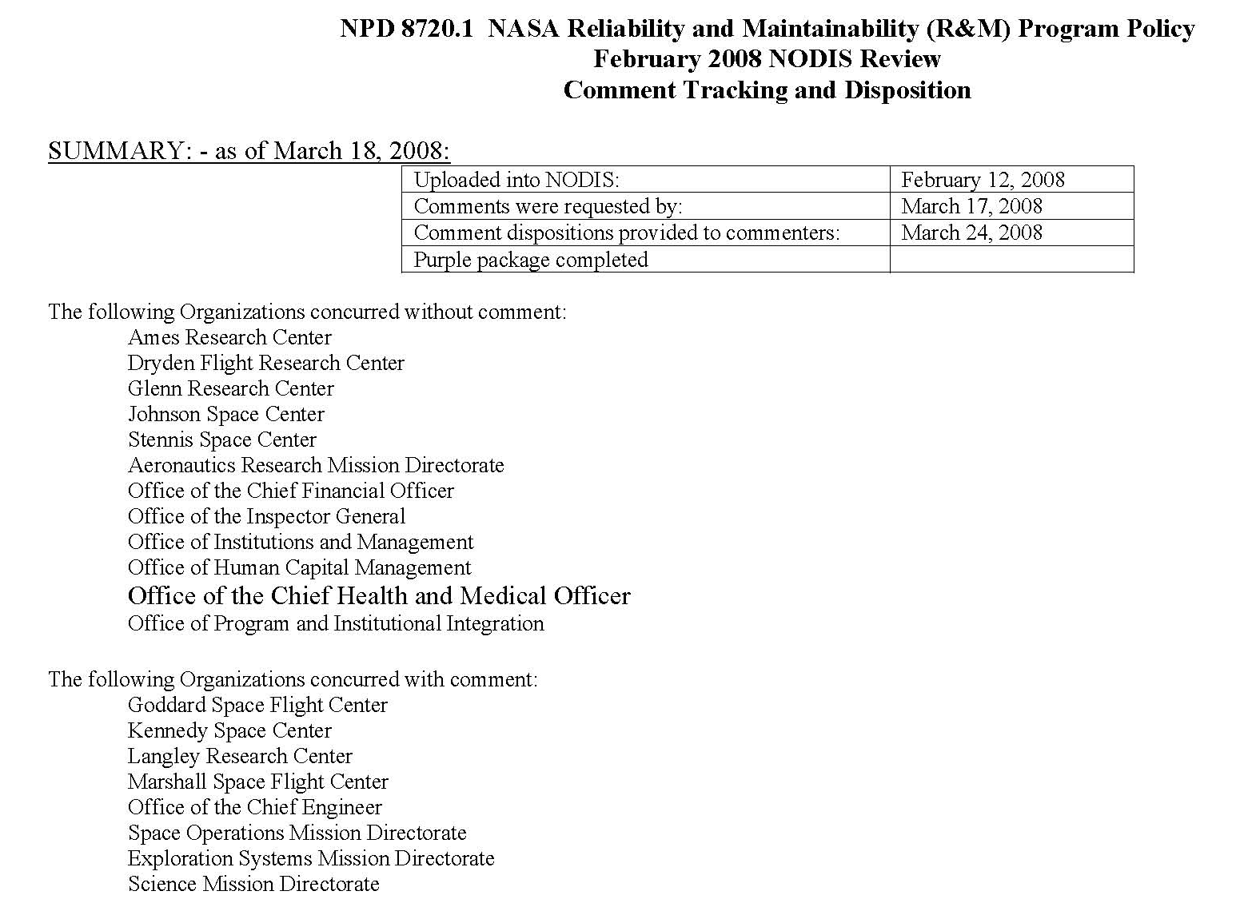
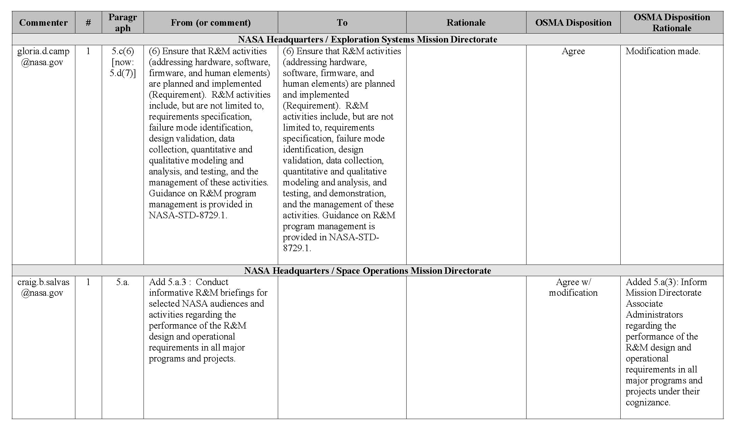
Sample 7: Executive Summary
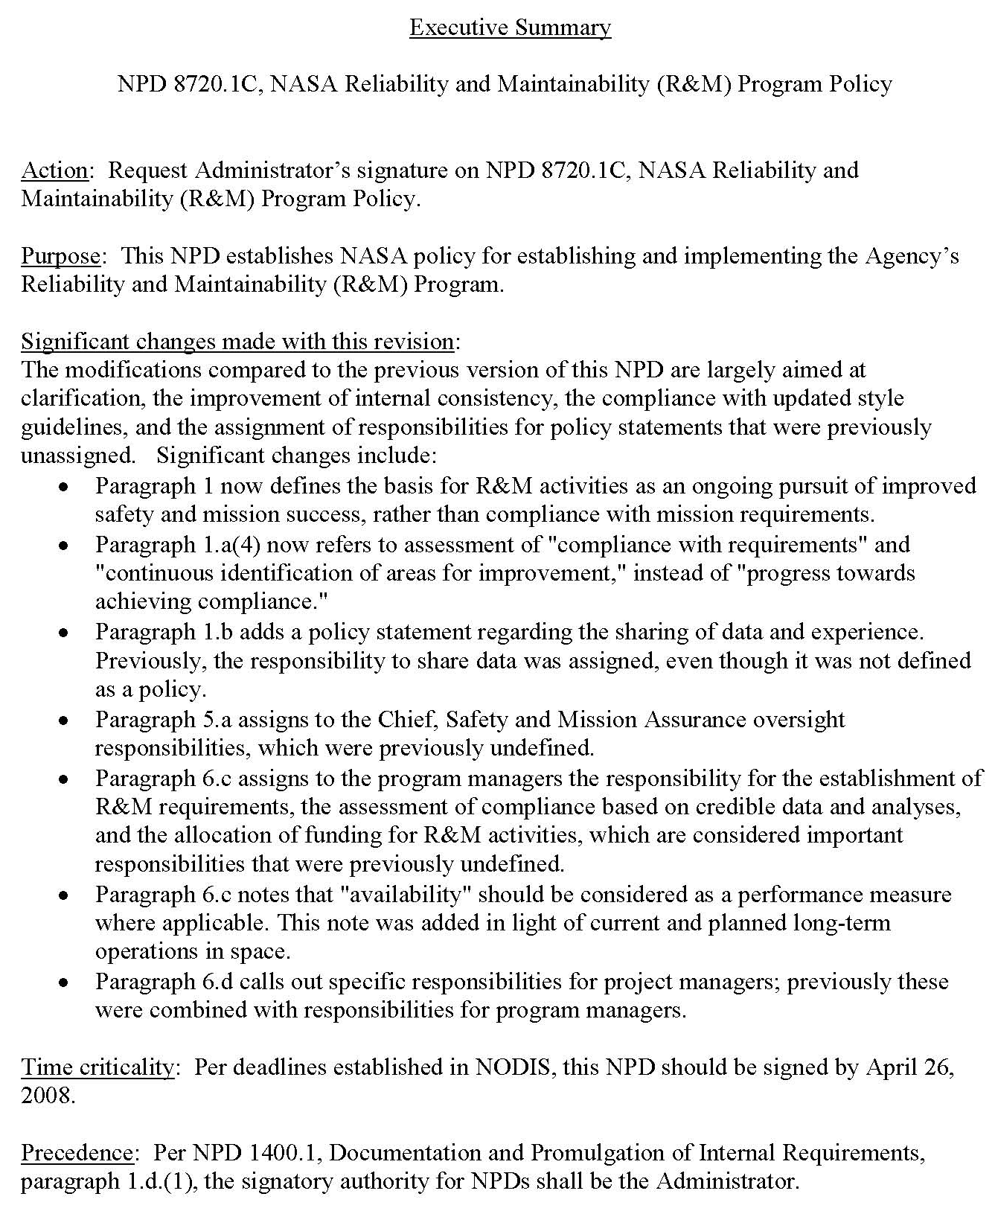
Sample 8: A-Suite Briefing
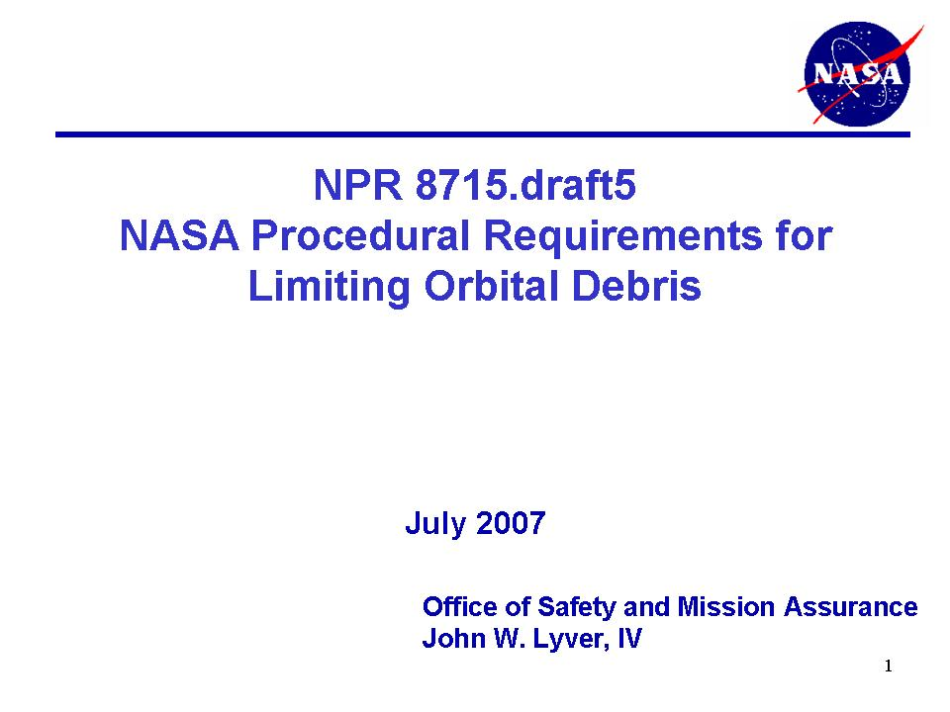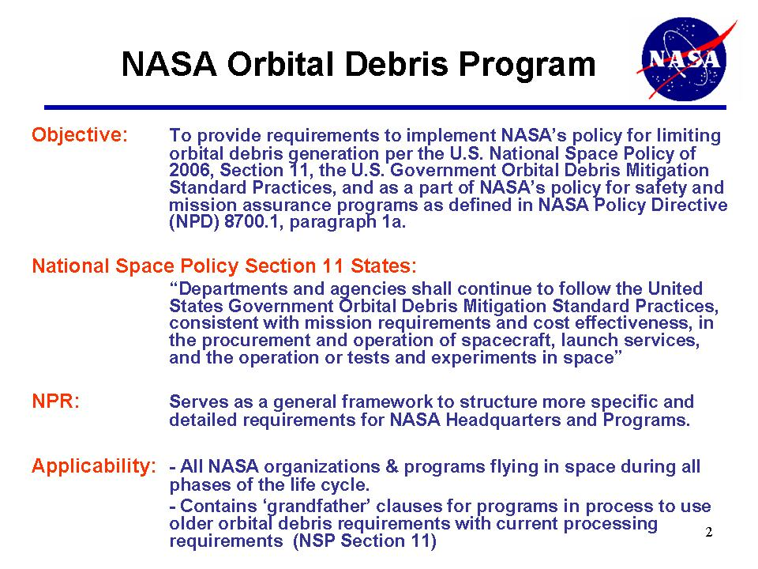

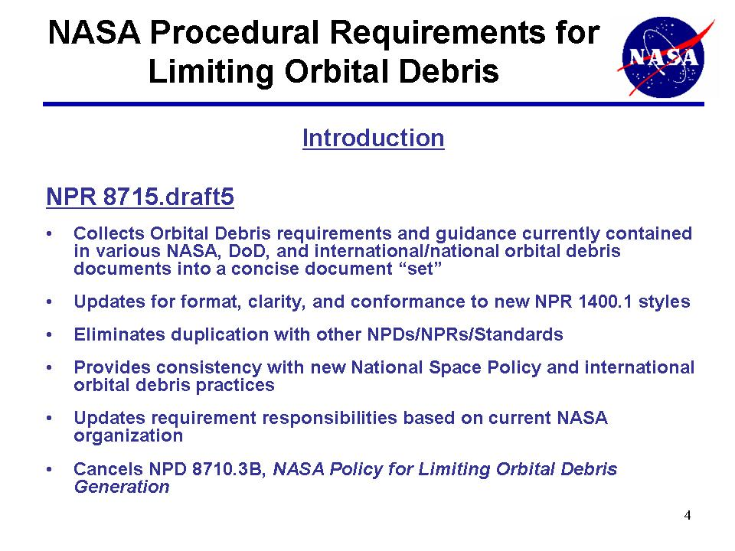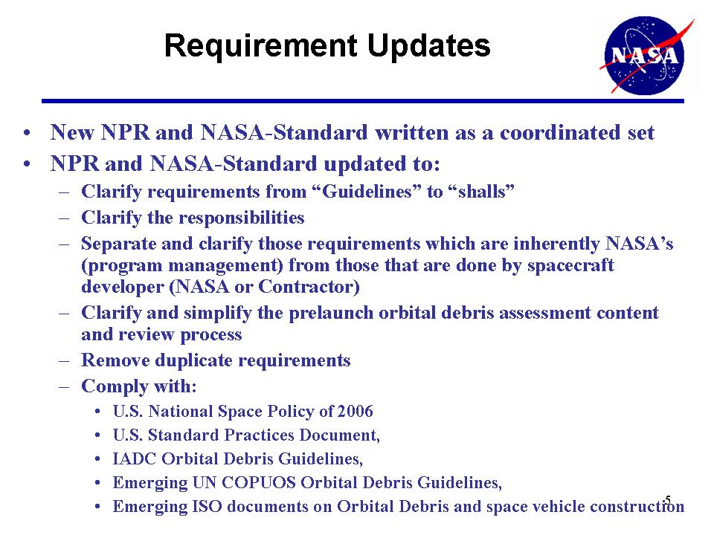

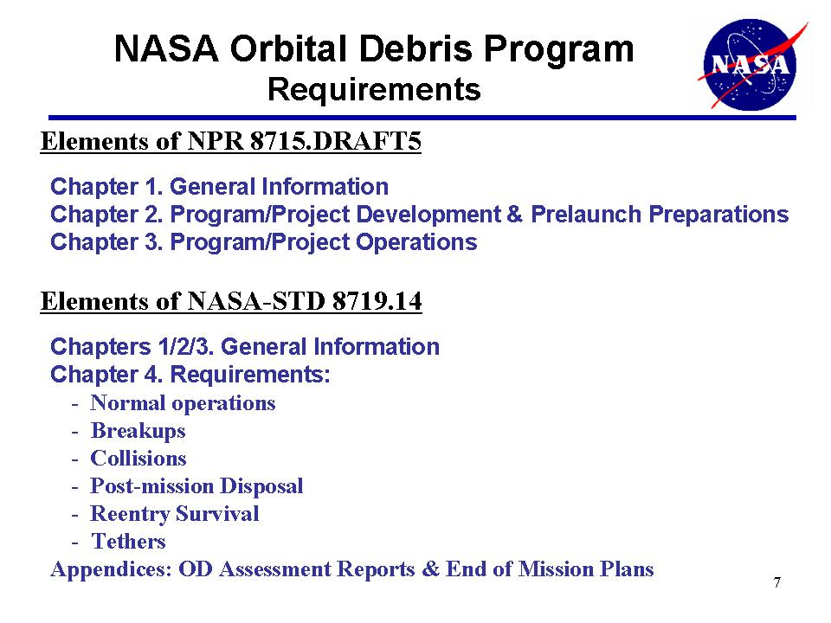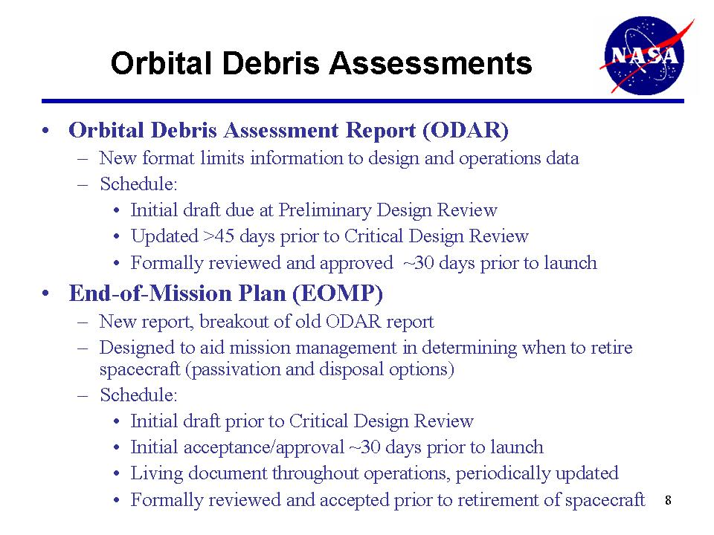
Appendix D: Documentation Type Selection Criteria
The document type is selected based on the type of information it will contain. For the document selection, the types of information include:
Policy: A statement of NASA-wide policy and overarching responsibilities.
NASA Requirements: Statements (aka: “shall statements”) which directly place requirements on NASA personnel and offices. Primarily these requirements are for program or institutional management personnel.
General Requirements: Statements which place requirements to those who are performing the function being regulated. This includes requirements which are performed by the contractor or the “NASA shop” performing the work. .
Supporting Information: Statements which do NOT contain mandatory requirements. This information is usually in the form of explanatory text, background information, suggested practices, and basic science. This information is generic to apply to many programs/projects.
Results Information: Results of studies or outputs from programs/processes.
Plans: Planning information for a specific mission/process.

Table D-1: Document Selection
Code | Use
X | Fully Used
o | Can contain
- | Very limited use

Document Type | Policy | NASA Reqmt | General Reqmt | Spt Info | Results | Plans
NASA Policy Document (NPD) | X | o
NASA Procedural Requirements (NPR) | - | X |  | o
NASA-Standard (NASA-STD)  [for programs/ projects] |  |  | X | o
NASA-Standard (NASA-STD)  [for facilities] |  | - | X | o
NASA Handbook (NASA-HDBK) |  |  |  | X | o | o
NASA Technical Reports |  |  |  | o | X | -
Agency-wide Plans |  |  |  |  |  | X
Appendix E: OSMA Document Tree and Drafts Website
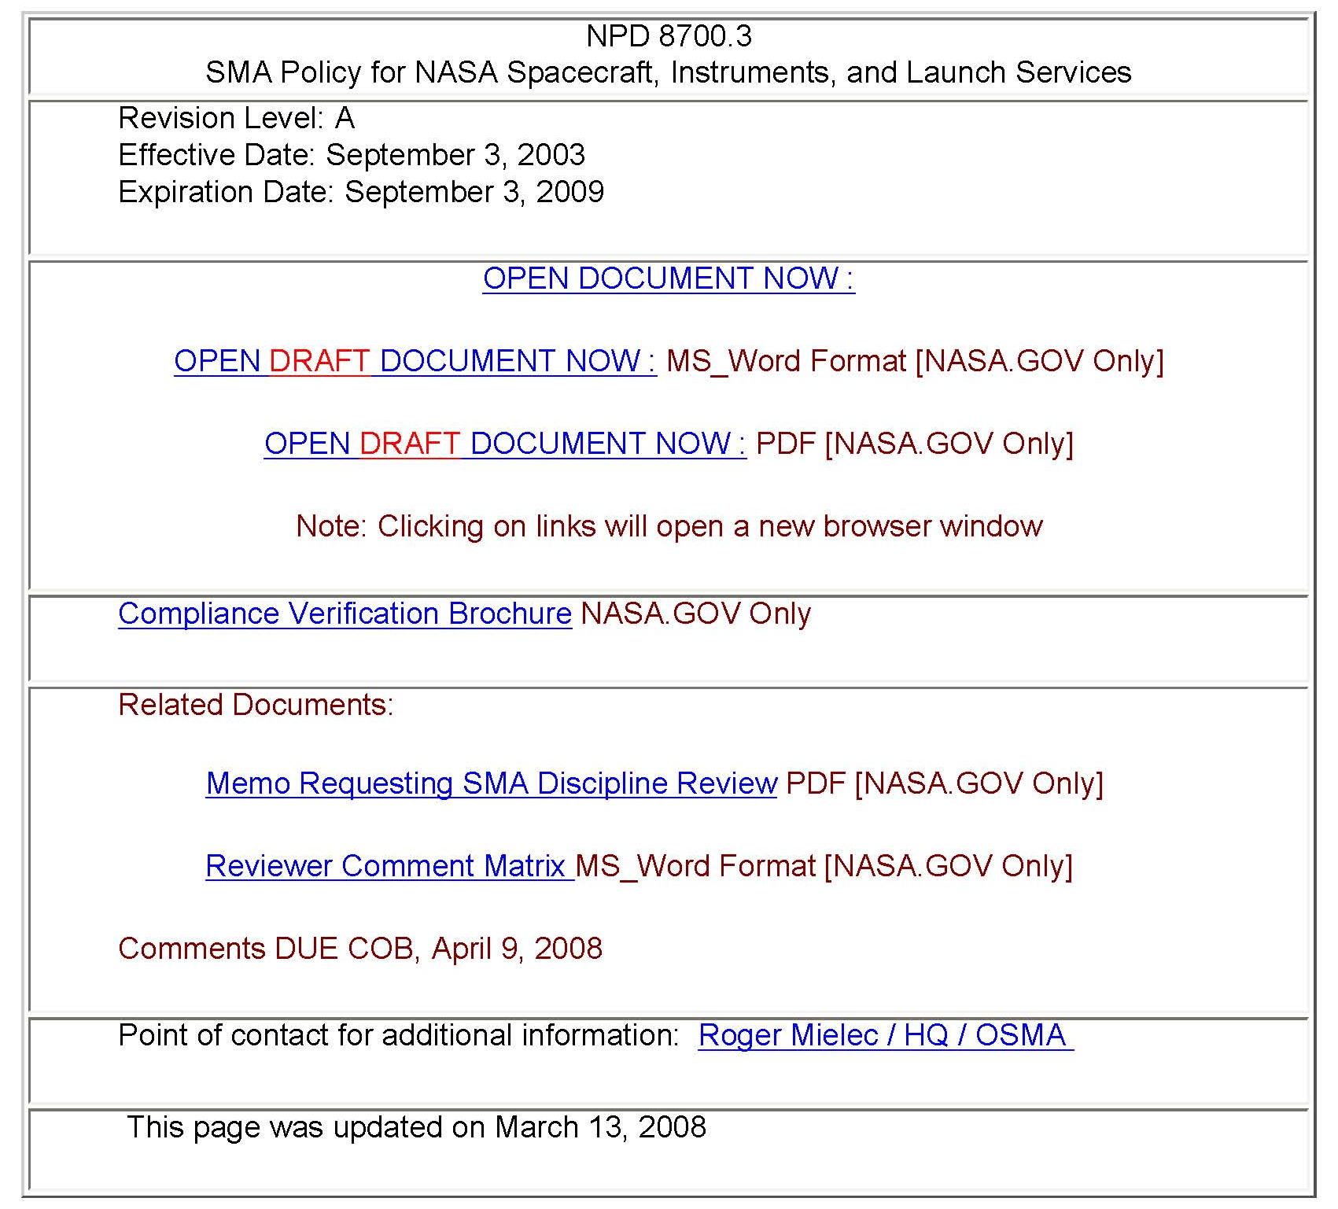
Metadata available for Released Documents
Document revision and dates
Document (MS Word and Adobe Acrobat [.pdf] versions)
Compliance Verification Brochure (.pdf only)
Link to SATERN and other training courses (if any)
Link to send POC an e-mail
Prior to SMA Discipline Review
Add: SMA Discipline Review Draft Document (MS Word [.doc] and .pdf versions)
Add: Memo Requesting SMA Discipline Review (.pdf only)
Add: Reviewer Comment Matrix (.doc only)
After SMA Discipline Review is completed
Remove: SMA Discipline Review Draft Document (all versions)
Add: Post SMA Discipline Review Draft Document (.pdf only)
Add: SMA Discipline Review Comment Distribution Matrix (.pdf only)
Prior to NODIS Review
Add: Link to NODIS for review draft
Remove: Post SMA Discipline Review Draft Document (.pdf only)
After OSMA comment dispositioning is complete after NODIS Review.
Add: Updated Post-NODIS Review Draft Document (.pdf only)
Add: NODIS Review Comment Distribution Matrix (.pdf only)
After Document is approved
Update all Metadata
Remove all change links.
Appendix F: OSMA Document Author/POC Responsibilities

The following information is summary of the responsibilities for the Document author/POC taken from Section 5 of this HOWI. Due dates will be provided by the OSMA Documentation Manager (DM).
- Coordinate assignment with Division Director for document update
- Prepare document and provide to DM for review/comment.
- DM and RL will update the formatting, review, provide comments, and updated draft.
- Update document and provide to DM: Document in MS Word, All supporting electronic files, and List of working group and peers who should review the document
- DM will update formatting, provide draft SARD Division Director request letter and draft comment submission form for Author review.
- Do final review before SARD Division Director releases for SMA Discipline. Provide materials back to DM.
- DM gets the SARD DD to request the review
- DM gets OSMA Webmaster to upload to the OSMA Drafts web page.
- DM sends a reminder note to all reviewers 2 weeks before comments are due.
- As comments come in, DM collates them and copies them to “U:/ Drive”
- When SMA Discipline Review is done, the DM will provide the comments and the Comment Distribution Matrix.
- Resolve ALL comments, update CDM and update draft. Provide to the DM for review.
- DM will review the comment dispositions for clarity and formatting. The comments will be placed on the OSMA Drafts web page and a note is sent to the commenters to review the CDM and provide comments back to the author.
- Resolve ALL comments, update CDM and update draft. Provide to the DM for review.
- DM and RL will review the document, update the draft with the author, get Union & OSHA reviews if needed and submit to NODIS as needed.
**Note: The DM/RL maintain the master document from this point forward **
- When Union, OSHA, NODIS reviews are done, the RL will provide the comments and the Comment Distribution Matrix on the “U:/ Drive”.
- For NODIS reviews, the Author will have to brief the A-suite about 2 weeks after the CDM and updated draft are complete.
- Prior to release, the Author will need to do a final review and help the RL with OSMA management signature processing.

