REVISION C



Management of the
Safety and Mission Success Review (SMSR) Process

__/S/_________________________ December 2, 2019
Terrence W. Wilcutt Date
Chief, Safety and Mission Assurance

DOCUMENT HISTORY LOG

Status (Draft/ Baseline/ Revision/ Canceled) | Document Revision | Effective Date | Description
Baseline |  | January 17, 2006
 | A | November 19, 2008 | Updated to reflect updates to NPR 8715.6 Chapter 4.
 | B | August 26, 2011 | Updated to reflect updates to NPR 8705.6B. Changes made to Purpose, definitions of BRS & EAV deleted, Reference to SMSR-05-01 deleted, editorial changes to Section 7.
 | C | September 30, 2019 | Editorial, organizational, and process changes to all sections.

HOWI Author: MPAD/Eric Raynor

OSMA Staff Member Responsible for this HOWI: MPAD/Deirdre Healey

Customers for this HOWI: Internal: Chief, Safety and Mission Assurance,
Chief Engineer, and Chief Health and Medical
Officer
External: Mission and Program/Project Management
Stakeholders

Purpose
The purpose of this Office of Safety and Mission Assurance (OSMA) Headquarters Office Work Instruction (HOWI) is to document the process of how OSMA prepares for and conducts Safety and Mission Success Reviews (SMSRs) and associated briefings and actions for the Technical Authorities (Chief, SMA; Chief Engineer; and Chief Health and Medical Officer). The SMSR prepares the Technical Authorities (TA) to make upcoming decisions at subsequent major milestone review forums, such as a Key Decision Point (KDP), a Flight Readiness Review (FRR), or a Mission Review Board (MRB), about overall readiness for a launch, a flight test, or some other high-visibility or high-risk NASA operation. The SMSR provides the knowledge, visibility, and understanding necessary for the TA to concur or non-concur with program decisions to proceed with an activity. This HOWI also specifies the Quality Records associated with the process.
The SMSR process typically includes:
- An examination of program/mission preparation status, open work issues and concerns,
- An assessment of overall systems readiness, as well as a review of any relevant independent assessments and minority report concerns, and
- An affirmation that the program/project has mitigated risks to an acceptable level.
SMSRs conclude with a readiness poll to help the TA determine readiness to proceed with the activity under review. A SMSR may be conducted by a NASA Field Center for program/project readiness reviews that are held at the Center level - this delegated SMSR is referred to as a Safety and Mission Success Assessment (SMSA); this HOWI can serve as a guide for the conduct of SMSAs as well.

Scope and Applicability
This HOWI is applicable to the OSMA, the OCE, and the OCHMO, as well as Mission and Program/Project Management stakeholders as required.

Acronyms/Definitions

CHMO: Chief Health and Medical Officer

CoFR: Certificate of Flight Readiness

Delta SMSR: A follow on event to a specific SMSR, when post-SMSR risks have arisen and require a formal briefing to the NASA Technical Authorities.

EAR: Export Administration Regulations

FRR: Flight Readiness Review

HOWI: Headquarters Office Work Instruction

ISMD: Institutional Safety Management Division

IT: Information Technology

ITAR: International Traffic in Arms Regulations

KDP: Key Decision Point

MASCD: Mission Assurance Standards & Capabilities Division

MRB: Mission Review Board

MPAD: Mission & Program Assessment Division

NASA: National Aeronautics and Space Administration

OCE: Office of the Chief Engineer

OCHMO: Office of the Chief Health and Medical Officer

OSMA: Office of Safety and Mission Assurance

Pre-SMSR: A preparatory SMSR event to review and clarify SMSR event procedures, logistics, and presentation content.

QMS: Quality Management System

SBU: Sensitive But Unclassified

SMA: Safety and Mission Assurance

SMSA: Safety and Mission Success Assessment (Center-delegated SMSR)

SMSR: Safety and Mission Success Review

SMSR Admin Team: The SMSR contractor support team.

SMSR Manager: The NASA manager for the SMSR program.

TA: Technical Authority

TAPS: Technical Authority to Proceed to SMSR

Reference Documents
The documents listed in this section are used as reference materials for performing the processes covered by the Quality Management System (QMS). Since all NASA Headquarters Level 1 (QMS Manual) and Level 2 (Headquarters Common Processes) documents are applicable to the QMS, they need not be listed in this section unless specifically referenced in this OSMA HOWI.

NPD 8610.24C: Launch Services Program Pre-launch Readiness Reviews

NPD 8700.1E: NASA Policy for Safety and Mission Success

NPR 7120.5E: NASA Space Flight Program and Project Management Requirements

NPR 7123.1B: NASA Systems Engineering Processes and Requirements

NPR 7150.2B: NASA Software Engineering Requirements

NPR 8000.4B: Agency Risk Management Procedural Requirements

NPR 8705.6C: Safety and Mission Assurance Audits, Reviews, and Assessments

NPR 8715.3D: NASA General Safety Program Requirements

NPR 8715.6B: NASA Procedural Requirements for Limiting Orbital Debris and Evaluating the Meteoroid and Orbital Debris Environments

NPR 8715.7A: Expendable Launch Vehicle Payload Safety Program

Flowchart
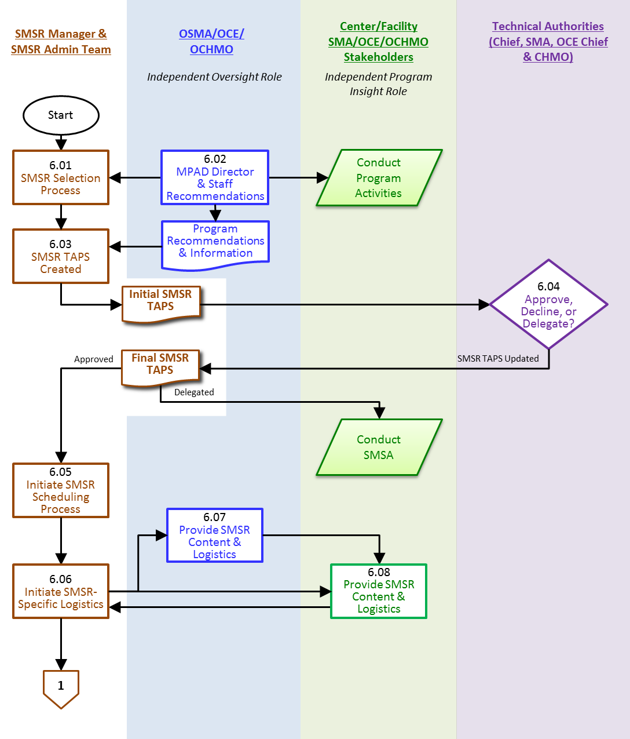
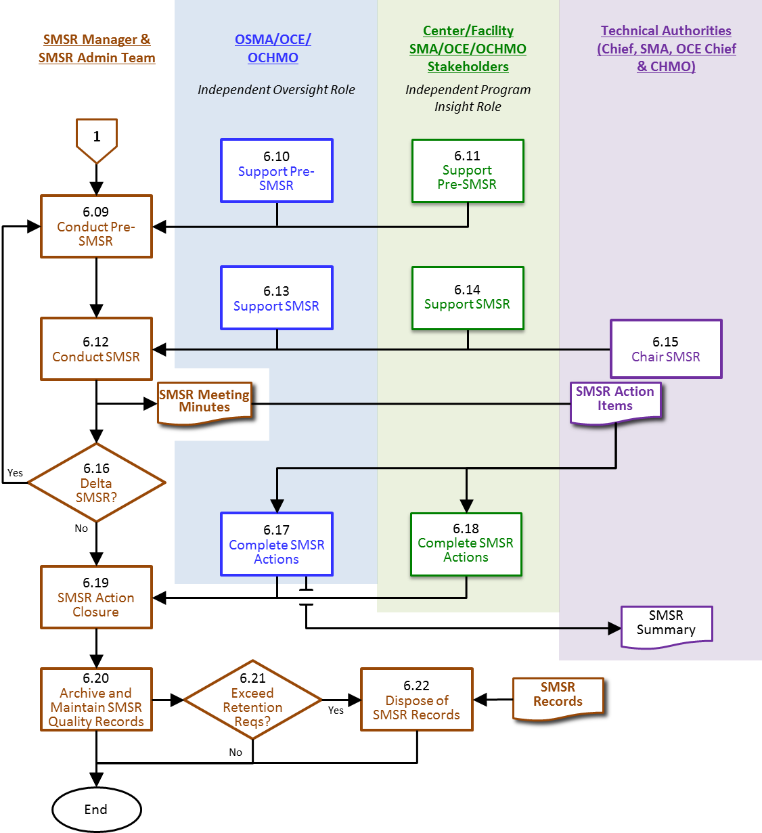

Procedure
  - SMSR Manager — SMSR Selection Process
The SMSR Manager queries the OSMA/MPAD staff for upcoming/planned missions requiring a SMSR. SMSRs are selected for the following reasons:
- Upcoming mission launch or reentry activity.
- Critical milestone in the program/project management life-cycle.
- Other high-risk/high-visibility program or project activity.
  - MPAD Director — MPAD Director & Staff Recommendations
OSMA/MPAD Director and staff provide recommendations to the SMSR Manager, based on their independent assessments of program or project risks, and the status of OSMA internal reviews related to those programs and/or projects.
  - SMSR Manager — SMSR TAPS Created
The SMSR Manager drafts the initial TAPS statement based on input received from OSMA/MPAD Director and staff and forwards to the TA for decision.
  - Technical Authorities — Approve, Decline, or Delegate?
The TA review TAPS recommendation and make a mutual determination to approve, decline or delegate the SMSR activity. Should opinions diverge, a SMSR or delegated SMSA can proceed when only one of the Chiefs deems it necessary; the process defaults to the higher-level review requested by any Chief.
  - SMSR Manager and SMSR Admin Team — Initiate SMSR Scheduling Process
SMSR Manager receives final TAPS and shares results with SMSR Admin Team.
  - SMSR Manager and SMSR Admin Team — Initiate SMSR-Specific Logistics
Once authority to proceed with a SMSR has been granted, the SMSR Manager and SMSR Admin Team:
- Updates and disseminates the SMSR Master Schedules,
- Adds the SMSR information to appropriate SMSR and shared data repositories,
- Requests agenda inputs from the OSMA/MPAD staff and Center/Facility SMA/OCE/OCHMO Stakeholders in preparation for the Pre-SMSR, and
- Schedules and administratively prepares for the Pre-SMSR.
  - OSMA/MPAD Staff — Provide SMSR Content & Logistics
Upon request, the OSMA/MPAD staff provides content and participant information for the SMSR and/or associated preparation meetings and gives it to the SMSR Admin Team.
  - Center/Facility Mission SMA/OCE/OCHMO Stakeholders — Provide SMSR Content & Logistics
Upon request, the Center/Facility Mission SMA/OCE/OCHMO Stakeholders provide content and participant information for the SMSR and/or associated preparation meetings and give it to the SMSR Admin Team. This input should include representation from the Program and Center SMA, engineering, health, and medical communities, as well as other mission stakeholders to include individuals or organizations which have performed independent assessments related to the upcoming activity.
  - SMSR Manager and SMSR Admin Team — Conduct Pre-SMSR
The SMSR Manager and SMSR Admin Team conduct the Pre-SMSR, and identify content and logistical changes/updates in preparation for the SMSR. The purpose of the Pre-SMSR is to:
- Explain the SMSR process for those who are not familiar with it;
- Review the SMSR presentation template;
- Identify any special topics, significant residual risks, or necessary status briefings;
- Identify any presentation special handling requirements:
- Sensitive But Unclassified (SBU),
- International Traffic in Arms Regulations (ITAR)/ Export Administration Regulations (EAR),
- Limited Rights, and/or
- Proprietary Data;
- Confirm the identification of presenters, attendees and persons to be polled;
- Confirm participant IT support needs for the SMSR;
- Refine schedule and agenda as needed; and
- Establish deadlines for delivery of presentation materials and for any open work identified during the Pre-SMSR.
  - OSMA/OCE/OCHMO Staff — Support Pre-SMSR
The OSMA/OCE/OCHMO Staff attend and/or support the Pre-SMSR as appropriate.
  - Center/Facility Mission SMA/OCE/OCHMO Stakeholders — Support Pre-SMSR
The Center/Facility Mission SMA/OCE/OCHMO Stakeholders attend and/or support the Pre-SMSR as appropriate.
  - SMSR Manager and SMSR Admin Team — Conduct SMSR
The SMSR Manager and SMSR Admin Team conducts the SMSR, which includes:
- Issue final meeting invitation and agenda;
- Confirm receipt and availability of SMSR presentations;
- Notify key participants of availability of SMSR presentation charts for preview prior to SMSR;
- Perform host role during the SMSR;
- Confirm and track action items and open work as required; and
- Conduct formal SMSR poll.
Quality records from the SMSR include:
- Official meeting minutes (audio recording and attendance records).
- Action Items.
  - OSMA/OCE/OCHMO Staff — Support SMSR
The OSMA/OCE/OCHMO Staff attend and/or support the SMSR, including the submission of presentations, as appropriate.
  - Center/Facility Mission SMA/OCE/OCHMO Stakeholders — Support SMSR
The Center/Facility Mission SMA/OCE/OCHMO Stakeholders attend and/or support the SMSR, including the submission of presentations, as appropriate.
  - Technical Authorities — Chair SMSR
The SMSR can be chaired by any combination of the Chief, SMA; the Chief Engineer; and the Chief Health and Medical Officer. If unavailable they may delegate to their deputies or an alternate.
  - SMSR Manager — Delta SMSR
A Delta SMSR may be identified as required at the conclusion of the SMSR based on the following:
- SMSR action items,
- Other identified open work, and/or
- A NO-GO polling result at the SMSR.
If a Delta SMSR is needed, the process returns to Step 6.09, otherwise the process continues.
  - OSMA/OCE/OCHMO Staff — Complete SMSR Actions
If action items are identified at the SMSR, OSMA/OCE/OCHMO Staff, as assigned, will work them to closure. If requested, OSMA, OCE and/or OCHMO staff will draft a summary of the SMSR proceedings for the Technical Authorities.
  - Center/Facility Mission SMA/OCE/OCHMO Stakeholders — Complete SMSR Actions
If action items and/or open work are identified at the SMSR, Center/Facility Mission SMA/OCE/OCHMO Stakeholders, as required, will work them to closure.
  - SMSR Manager and SMSR Admin Team — SMSR Action Closure
The SMSR Manager accepts action items for closure from SMSR action item recipient.
  - SMSR Manager and SMSR Admin Team — Archive and Maintain SMSR Quality Records
The SMSR Manager and SMSR Admin Team retain SMSR Quality Records in the SMSR data repositories per current NASA retention policy:
- The SMSR Meeting Minutes
- The SMSR Action Item log
- Presentation files
  - SMSR Manager and SMSR Admin Team — Exceed Retention Requirements?
When SMSR Quality Records reach their minimum retention requirement, the SMSR Manager has the option, on a case-by-case basis, to maintain the Quality Records for a longer duration.
  - SMSR Manager and SMSR Admin Team — Dispose of SMSR Records
SMSR Quality Records are disposed per NASA records disposal requirements. Special disposal procedures are followed for SMSR Quality Records that include:
- SBU
- ITAR/EAR
- Limited Rights
- Proprietary Data

Quality Records
Record ID | Owner | Location | Media Electronic /hardcopy | Retention & Disposition
SMSR TAPS | SMSR Manager | OSMA Flight Projects Dashboard | Electronic | TBD
SMSR Action Item Log | SMSR Manager | MPAD File Repository | Electronic | Cutoff at the end of the Fiscal or Calendar year. Destroy 3 years after cutoff or when no longer needed for business purposes, whichever is later.  (1700 series) in NRRS 1441.1, 2017 edition
SMSR Meeting Minutes
SMSR Presentation Files
SMSR Voice Recording

