REVISION F



NASA Safety Reporting System

__/s/__________________________ 5/7/2019
Terrence W. Wilcutt Date
Chief, Safety and Mission Assurance

DOCUMENT HISTORY LOG

Status (Draft/ Baseline/ Revision/ Canceled) | Document Revision | Effective Date | Description
Baseline |  | February 17, 2000
Revision | A | November 14, 2000 | Editorial Corrections to Sections 1, 5 Flowchart, and steps 6.07, 6.10, 6.11, and 6.13.
 | B | February 1, 2002 | Changed HOWI Author. Added Customer list. Editorial correction to definition in section 3.2, references 4.7 and 4.7, and step 6.07. Process explanation added to section 6 introduction and step 6.15. Changed steps 6.16 and 6.17 and Appendix A form.
 | C | March 31, 2004 | Editorial and organizational changes to all sections.
 | D | February 2, 2006 | Updated to new organizational structure
 | E | March 15, 2012 | Updated to new organizational structure
 | F | April 29, 2019 | Editorial, organizational, and process changes to all sections. Added new steps 6.15, 6.16, 6.18-6.20, and 6.22-6.34. Modified Appendices.

HOWI Author: MSD/NSRS Program Manager/Eric Raynor

OSMA Staff Member Responsible for this HOWI: MSD Director/Deirdre Healey

Customers for this HOWI: Internal: Chief/SMA
External: NASA personnel

Purpose
The purpose of the Office of Safety and Mission Assurance (OSMA) Headquarters Office Work Instruction (HOWI) is to document the administrative process for the NASA Safety Reporting System (NSRS).

Scope and Applicability
This HOWI applies to the OSMA, NASA Center, and Jet Propulsion Laboratory (JPL) staff members who manage or support the NSRS (and its support contractor) process and the OSMA management in their review of these efforts. The following personnel are involved with the management of the NSRS:
- The contractor-operated NSRS Administrative Office (NAO).
- The NASA HQ Office of Safety and Mission Assurance (OSMA).
  - Chief, Safety and Mission Assurance (Chief, SMA).
  - Deputy Chief, SMA.
  - Director, Mission Support Division (Dir. MSD).
  - NSRS Program Manager (NSRS PM).
  - NSRS Contracting Officer Representative (NSRS COR).
  - Mission Support Division Staff.
- Center and Component Facility Safety and Mission Assurance staff, as designated by the Center/Component Facility Director of Safety and Mission Assurance.
- NSRS Report Authors (NSRS RA).

Definitions

Anonymous (with respect to the NSRS Process): NSRS RA’s identities will not be disclosed to NASA - except in cases where waste, fraud, abuse, or gross mismanagement have been alleged, in which cases identities will be provided directly from the NAO to the NASA Inspector General (IG). No information submitted by an NSRS RA will be used directly or indirectly as a means to purposefully expose the identity of any report author.

CAP: Corrective Action Plan

CO: Contracting Officer

COR: Contracting Officer Representative

De-identified NSRS Report (dNSRS): An NSRS report that has been stripped of any references to the NSRS RA’s identity so as to protect the RA’s anonymity in reporting. This product is created by the NAO prior to forwarding the report to the NSRS PM.

HOWI: Headquarters Office Work Instruction

IG: Inspector General

IT: Information Technology

JPL: Jet Propulsion Laboratory

NASA: National Aeronautics and Space Administration

NPD: NASA Policy Directive

NPR: NASA Procedural Requirements

MSD: Mission Support Division

NRRS: NASA Records Retention Schedules

NSRS: NASA Safety Reporting System

NSRS Administrative Office (NAO): The office of the NSRS support contractor who administers the NSRS program and works in close coordination with NSRS PM and the NSRS COR.

NSRS Program Manager (NSRS PM): The lead civil-service program manager responsible for the overall administration of the NSRS program, ensuring the prompt and thorough investigation and satisfactory closure of all NSRS investigative case reports. This person is designated by the Chief SMA and reports directly to the Dir. MSD.

NSRS Report Author (NSRS RA): Person making the NSRS report, which can be a civil service employee, a NASA contractor, or a member of the general public.

OCSHA: OSMA Center SMA Health Assessment

OSMA: Office of Safety and Mission Assurance

PDF: Abode’s Portable Document Format

PII: Personally Identifying Information

PM: Program Manager

QMS: Quality Management System

Report Closure: The approval for closure of an NSRS investigative case by the NSRS PM and the Dir. MSD.

SBU: Sensitive But Unclassified

SMA: Safety and Mission Assurance

Reference Documents
The documents listed in this section are used as reference materials for performing the processes covered by the Quality Management System (QMS). Since all NASA Headquarters Level 1 (QMS Manual) and Level 2 (Headquarters Common Processes) documents are applicable to the QMS, they need not be listed in this section unless specifically referenced in this OSMA HOWI.

NPD 8700.1: NASA Policy for Safety and Mission Success.

NPR 8715.1: NASA Occupational Safety and Health Programs.

NPR 8715.3: NASA General Safety Program Requirements.

Please refer to the OSMA website, policies section, at https://sma.nasa.gov/policies/all-policies or NASA Online Directives Information System (NODIS) at https://nodis3.gsfc.nasa.gov to verify latest versions of the documents identified in 4.1 through 4.3 above prior to use.

Flowchart

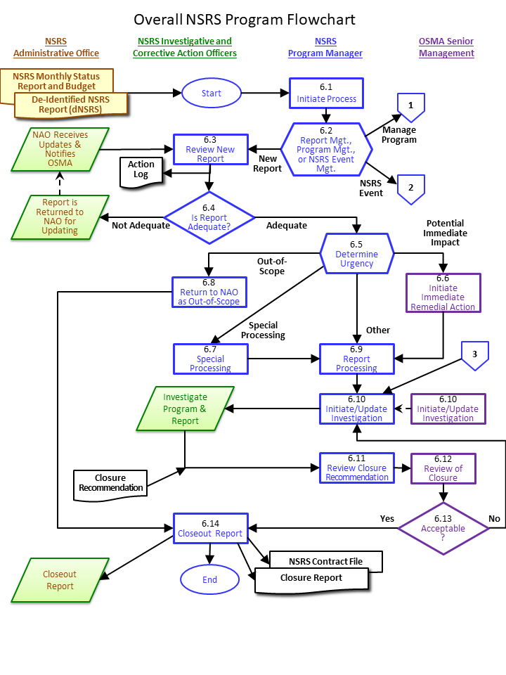
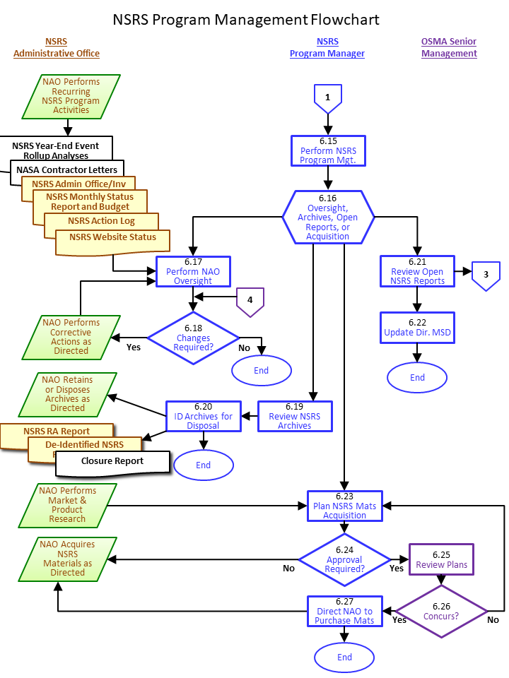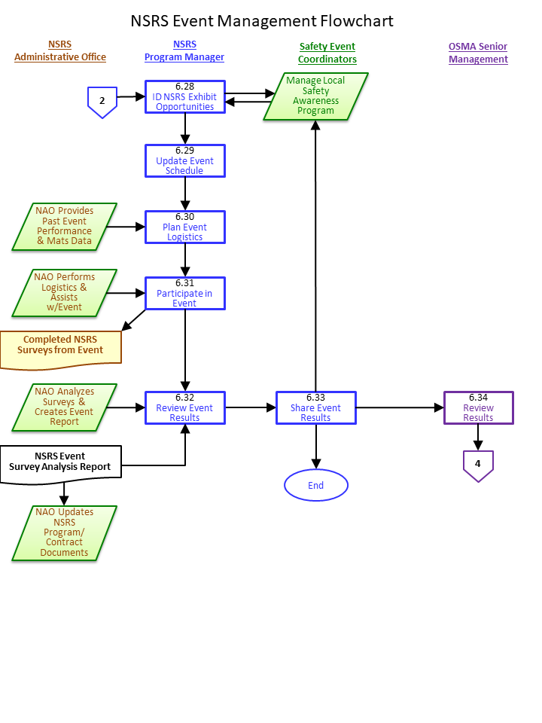

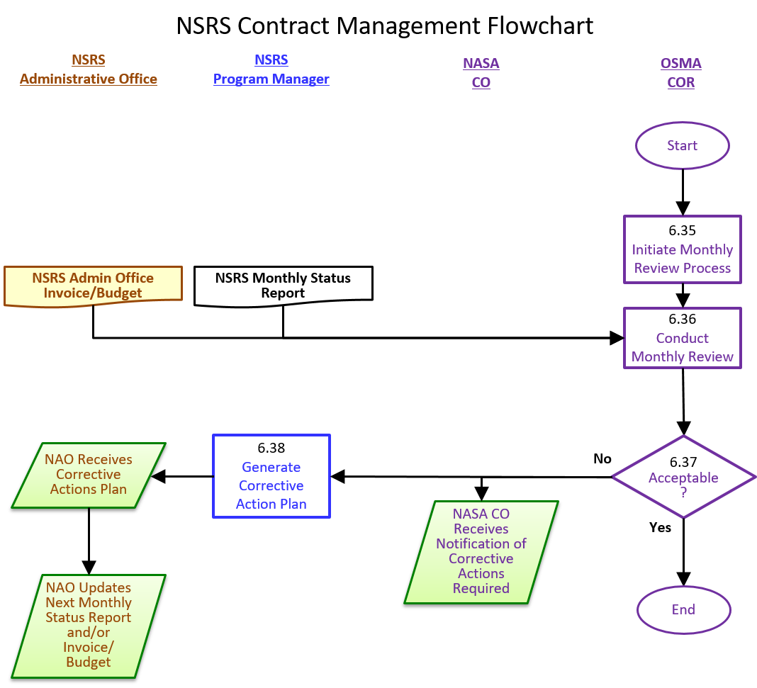Procedure
Note: ALL NSRS Report processing MUST ensure ANONYMITY of the NSRS RA.
The NAO:
- Retrieves a new NSRS report from the NSRS mailbox.
- Conducts an initial screening of the report for urgency.
- Communicates to the NSRS PM that a new report has been received and will be processed, as well as an initial assessment of urgency.
  - Typically, the NSRS PM is alerted by telephone in advance to expect the incoming dNSRS. If the NSRS PM is not available, the Dir. MSD or the NSRS PM’s designated alternate is telephoned/contacted.
- Creates the dNSRS by assigning an NSRS accession number and removing identifying information concerning the NSRS RA from the report.
- Checks report submission to confirm if any attempts have been made to address or resolve the concerns by other reporting means.
- Checks to see if any other NSRS reports have been submitted on the same or similar topics.
- Forwards the dNSRS to the NSRS PM by encrypted email or other means as approved by the NSRS PM.
- The dNSRS includes:
  - Report accession number.
  - Date the original report was received by the NAO.
  - Date the dNSRS was forwarded to the NSRS PM.
  - Type of concern and location.
  - Whether or not the NSRS RA has attempted to resolve the issue locally or by other avenues.
  - Summary of potential for harm/consequences if no action is taken.
  - Whether or not the NSRS RA provided identifying and/or point-of-contact information with the original report.
  - Mailbox to which the report was sent and information about any cancellation post-mark on the NSRS report.
  - Detailed de-identified report summary.
  - Signatures by two authorized NAO personnel certifying the accuracy and quality control of the dNSRS.
  - NSRS PM Initiate Process:
The NSRS PM initiates one of the following processes:
  - NSRS report management.
  - Monthly/program management.
  - NSRS event management.
  - NSRS PM Report Management, Program Management, or NSRS Event Management:
If there is a new NSRS report, the process continues with step 6.3, if there is a new program management action, the process continues with Step 6.15, or if there is a new NSRS event management action, the process continues with Step 6.28.
  - NSRS PM Review New Report:
- The NSRS PM reviews the dNSRS for adequacy.
  - A complete dNSRS has adequate information provided to evaluate the reported concern.
  - This evaluation is based on the professional background and precedence/experience with previous, similar dNSRS evaluated by the NSRS PM and/or the Dir. MSD.
- The NSRS PM creates and attaches a NSRS Action Log (See Appendix) to the dNSRS file.
  - NSRS PM Is Report Adequate?
- If the NSRS PM identifies a need for additional information based on an initial review of the dNSRS, then the dNSRS is returned to the NAO for additional data gathering. Otherwise, the process continues.
- The Action Log is updated if the dNSRS is returned to the NAO. If there is a need for additional information to clarify the understanding of the situation or to proceed with an investigation and/or resolution of the problem, the NSRS PM directs the NAO to obtain more information from the NSRS RA - this is known as a “callback.” In these cases, a callback to the NSRS RA (if NSRS RA can be identified) is completed as soon as possible after the NAO receives the request to do so from the NSRS PM. Callbacks may be required if the dNSRS does not adequately explain what, why, how, when, and under what circumstances the hazard or safety issue exists, or does not describe expected impacts if the hazard or safety issue is not corrected. Additional callbacks may be requested by the NSRS PM as required.
  - NSRS PM Determine Urgency:
The NSRS PM reviews each dNSRS for the following items to determine the appropriate next step in processing.
- The NSRS PM reviews the dNSRS for urgency. If the dNSRS appears urgent, the Dir. MSD is immediately notified about the dNSRS. Immediate remedial action may be required. See Step 6.6 below.
- A dNSRS that is deemed out-of-scope of the NSRS is closed out. The NSRS PM and/or the Dir. MSD may decide to refer such cases to other NASA organizations or non-NASA entities for information and action as appropriate. See Step 6.8 below.
- The NSRS PM determines if a dNSRS requires any special processing. See Step 6.7 below. Examples may include but are not limited to a dNSRS which contains:
  - National security, classified, or Sensitive But Unclassified (SBU) information.
  - Proprietary and/or limited rights information.
  - Personally Identifying Information (PII) which, if removed from the dNSRS, would make it difficult or impossible to adequately investigate.
  - Alleged criminal activity, which requires the NASA Inspector General (IG) office be notified immediately.
  - Content involving very high profile NASA or contractor personnel.
  - Content involving high profile or interest missions.
The Action Log is annotated accordingly to indicate if the dNSRS is urgent processing, out-of-scope, or special processing.
  - OSMA Senior Management Initiate Immediate Remedial Action:
The Dir. MSD (or the NSRS PM, at their behest) notifies the NASA SMA Offices and NASA management officials that are/should be involved with the NSRS report. Notification will be limited to the general nature of the report and any possible immediate remedial action that may be required. The selection of persons who are notified is based on the nature of the NSRS report (the breadth of the problem and its potential effects) as well as precedence used in processing. The Dir. MSD (or designee) maintains anonymity of the NSRS RA. The goal of this notification to initiate immediate remedial action is to prevent further hazard propagation, not to investigate the reported problem.
  - NSRS PM Special Processing:
The NSRS PM will define any special processing needed for the dNSRS and add cover instructions to the report as required. The NSRS PM will ensure that the special processing is maintained throughout the investigation of the dNSRS.
  - NSRS PM Return to NAO as Out-of-Scope:
The NSRS PM returns the dNSRS to the NAO with direction that the report is to be identified as out-of-scope and closed out. Proceed to Step 6.14.
  - NSRS PM Report Processing:
When RA identity is known, the NSRS PM directs the NAO to retain the original NSRS report form and return the identification strip to the NSRS RA.
The NSRS PM ensures that the report accession number and investigative status of the report is added to the NSRS status web page at https://sma.nasa.gov/sma-disciplines/nsrs/status. The NSRS PM notifies the Dir. MSD and other OSMA personnel having interest in the reported incident.
  - NSRS PM Initiate/Update Investigation:
The NSRS PM deliberates with the Dir. MSD; the Chief, SMA; and the Deputy Chief, SMA (and other NASA and non-NASA entities having interest in the reported incident) to determine how the dNSRS should be investigated and by whom it will be investigated. The goal of the investigation is to determine whether or not there actually is a safety issue or hazardous situation, and, if so, determine how best to mitigate and correct the problem, prevent further safety hazard propagation, and to investigate without laying blame or uncovering the identity of the reporter. The initial assessment to determine how to investigate and who should investigate is influenced by several factors that include:
- Urgency/Scope – how urgent and/or widespread does the safety situation or hazard appear to be? At what levels of management has the NSRS RA previously tried to address or resolve the concern?
- Subject Matter/Content – does the specific nature of the concern appear to effect institutional, programmatic, and/or functional types of activities?
Based on the initial assessment results, the NSRS PM assigns an individual or team of individuals to investigate and/or execute appropriate corrective action measures. These individuals or team members are typically chosen from among OSMA and Center civil service safety personnel at NASA, but can also include representatives from other NASA program and functional disciplines. In cases where a team is formed to investigate and/or execute corrective actions, a lead investigator/action officer(s) is identified to conduct the overall investigation and/or corrective action process.
The investigation will identify if a valid safety issue is discovered, and, if so, the responsible organization’s corrective action process will oversee the development and implementation of a corrective action plan and will track to closure the completion of corrective actions.
Generally, a written status report is due to the NSRS PM every 30 days to 90 days until the issue is satisfactorily resolved. More frequent reporting may sometimes be required in cases where the nature of the concern requires more urgent processing. The Action Log and NSRS status web page are updated as required throughout this process step, to show assignments made and directions given.
This step may also be reached as an output of Step 6.13 or 6.21. In these steps additional guidance or direction was determined to be needed for the processing or closure of the dNSRS. This may be due to urgency, other similar reports, unacceptable closeout rationale, or any other reason deemed necessary in the opinion of the NSRS PM, the Dir. MSD, or the Chief SMA. The NSRS PM provides the additional guidance to the lead investigator.
To protect RA anonymity, investigators must direct any questions about dNSRS to the NSRS PM or Dir. MSD.
If any investigator inadvertently discovers or strongly suspects a RA identity, they must notify the NSRS PM and recuse themselves from further involvement in the investigation.
  - NSRS PM Review Closure Recommendation:
Once the investigation and all corrective actions have been completed, the investigative lead provides a recommendation for closure of the dNSRS, along with a closure rationale in writing, to the NSRS PM. Justification of the investigators’ closeout recommendation is based on the input and concurrence of NASA Center senior management and safety officials. A closure recommendation from a dNSRS investigator should be submitted using a NSRS closure format provided by the NSRS PM, which generally calls for three concurrences/signatures before it will be considered for closure by the NSRS PM:
1) The concurrence/signature of the lead investigator,
2) The concurrence/signature of the Center/Component Facility SMA Director at the facility where the hazard has been identified and investigated, and
3) The concurrence/signature of the line-manager who resides at a management level one step above the level where management decisions would normally be made for the process in question.
The NSRS PM reviews the closure package and coordinates it with NASA Headquarters personnel that have responsibility in the reported area as well as the Dir. MSD; Chief, SMA; and Deputy Chief, SMA. The time required to officially complete the close out of a report may vary depending on the nature of the report.
When the report is ready to be closed, the NSRS PM then certifies the satisfactory resolution of the safety issue in writing on the Action Log. The NSRS PM can then recommend closing the file to the Dir. MSD.
  - OSMA Senior Management Review of Closure:
The Dir. MSD; Chief, SMA; and Deputy Chief, SMA will review for concurrence the closure package provided by the NSRS PM.
  - OSMA Senior Management Acceptable?
If the closure is acceptable, then Dir. MSD signs the Action Log and the dNSRS is closed out. Otherwise, the NSRS PM is directed to continue the investigation process. See Step 6.10 above.
  - NSRS PM Closeout Report:
After approval, the NSRS PM completes and signs the NSRS Report Action Log which has been included as a cover sheet for the report (see the Appendix for a sample). The NSRS PM assigns final classification and status codes and ensures updates are made to the NSRS status page accordingly. The dNSRS investigative file and records are forwarded to the NAO for secure storage and safekeeping. See the Appendix.
The NSRS PM directs the NAO to enter the final resolution codes into the NSRS monthly reporting documentation along with the date of closure for all NSRS issues, completing the action on the report. When quality records have been filed, then the process is closed out.
  - NSRS PM Perform NSRS Program Management:
- The NSRS PM performs one of the following processes:
  - Oversee NAO activities.
  - Review NSRS archives.
  - Review open NSRS reports.
  - Plan the acquisition of NSRS materials.
  - NSRS PM Oversight, Archives, Open Reports, or Acquisition:
- NSRS PM convenes monthly with NAO personnel to review recent and ongoing NAO status and activities, which includes open report status, archive status, and material needs.
  - NSRS PM Perform NAO Oversight:
- The NSRS PM reviews the NSRS program/budget documentation provided by the NAO. This includes, but is not limited to the following items:
  - On a monthly basis- the current Monthly Status Report and Budget documents, the NSRS Website Status summary, previous NSRS event survey results, the list of open NAO actions, and the NAO NASA IT access list.
  - On a quarterly basis- outreach letters to new NASA contractors.
  - On an annual, year-end, or ad-hoc basis- NSRS event rollup reports and annual inventory/NSRS PM NAO office visits.
  - NSRS PM Changes Required?
If after review, changes or updates are needed to any of the items in Step 6.17, the NAO is directed by the NSRS PM to update those items.
  - NSRS PM Review NSRS Archives:
The NSRS PM visits the NAO office to review the NSRS record archives.
  - NSRS PM Identify Archives for Disposal:
The NSRS PM identifies records for disposal as appropriate in accordance with NASA retention schedules.
  - NSRS PM Review Open NSRS Reports:
The NSRS PM reviews the status of open NSRS Reports. The investigation or corrective action lead is contacted for status. See Step 6.10 above.
  - NSRS PM Update Director, MSD:
The NSRS PM updates the Dir. MSD with any changes in open report status, as necessary. After having done so or if no updates are required, the review open reports process is completed until the next cycle.
  - NSRS PM Plan NSRS Materials Acquisition:
The NSRS PM and the NAO, on an ad-hoc basis, discuss and plan NSRS material needs.
  - NSRS PM Approval Required?
Material acquisitions require NSRS PM approval and, in some cases, may also require Dir. MSD approval.
  - OSMA Senior Management Review Plans:
The Dir. MSD reviews the acquisition plans provided by the NSRS PM.
  - OSMA Senior Management Concurs?
The Dir. MSD provides concurrence with the acquisition plans or directs reanalysis by the NSRS PM. See Step 6.23 above.
  - NSRS PM Direct NAO to Purchase Materials:
The NSRS PM directs the NAO to purchase the materials identified in the approved acquisition plans.
  - NSRS PM Identify NSRS Exhibit Opportunities:
The NSRS PM communicates with NASA Center and Component Facility Safety Event Coordinators to identify and schedule upcoming NSRS exhibit opportunities.
  - NSRS PM Update Event Schedule:
The NSRS PM updates and publishes the NSRS exhibit schedule.
  - NSRS PM Plan Event Logistics:
The NSRS PM meets as required with the NAO to plan and prepare for specifics for each NSRS event. The NAO will package and send NSRS materials as needed to the exhibit locations.
  - NSRS PM Participate in Event:
- The NSRS PM, either alone or with additional support from the NAO:
  - Sets up the NSRS exhibit booth.
  - Staffs the booth.
  - Conducts NSRS surveys.
  - Distributes NSRS information awareness materials.
  - Conduct onsite and offsite test mailings.
  - Disassembles the exhibit and coordinates the return of the exhibit materials to the NAO.
  - NSRS PM Review Event Results:
The NSRS PM reviews the NSRS event survey results tabulated by the NAO, and compares those results with results from previous events at the same location/event.
  - NSRS PM Share Event Results:
The NSRS PM provides event survey results to Dir. MSD, other HQ OSMA managers as appropriate, and the NASA Center or Component Facility lead Safety and Mission Assurance official.
  - OSMA Senior Management Review Results:
The Dir. MSD reviews the event survey results. These results are incorporated into the Dir. MSD’s submission to the OSMA Center SMA Health Assessment (OCSHA) report.
  - NSRS COR Initiate Monthly Review Process:
The NSRS COR has the responsibility and authority to monitor all aspects of the day-to-day administration of the NSRS contract. To meet this responsibility the NSRS COR performs monthly reviews with the NAO and the NSRS PM to identify and resolve issues. Should the NAO in monitoring specified aspects of NAO performance, including:
- Ensuring that the NAO complies with all statement of work requirements;
- Monitoring and evaluating the NAO’s performance to determine if they meet the standards set forth in the contract by the delivery date(s) and within the period of performance;
- Evaluating whether the NAO performs within the price or estimated cost stated in the contract; and
- Reviewing the NAO’s invoices for reasonableness and applicability to the contract. The NSRS COR recommends approval or rejection for all invoices.
  - NSRS COR Conduct Monthly Review:
The NSRS COR reviews and verifies the monthly report documentation.
  - NSRS COR Acceptable?
If changes are needed to the monthly report documentation, the NASA COR notifies the NASA CO and directs the NSRS PM to develop a Corrective Action Plan (CAP). If no changes are required, the process is closed out.
  - NSRS PM Generate Corrective Action Plan
The NSRS PM develops a CAP for the NAO to implement and provides it to the NAO for incorporation in the next monthly cycle of report documentation.

Quality Records
Record | Owner | Location | Media Electronic /hardcopy | Retention & Disposition
Original Report | NAO | NAO | Hardcopy | Destroy or delete 1 year after suggestion disposition or when no longer needed for business purposes, whichever is later.  (1700 series) in NRRS 1441.1, 2017 edition
dNSRS Report | NSRS PM | NAO | PDF & Hardcopy
Closure Report | NSRS PM | NAO | Hardcopy
Note: Destruction of Quality Records may only be done with the permission of the NSRS PM.
Note: All NSRS Records being held by the NAO will be transitioned to a new contractor or returned to OSMA prior to the end of the contract or upon direction of the NSRS PM or COR.

Appendix: NSRS Forms
The NSRS forms to be used are presented on the following pages for:
- NSRS Action Log
- NSRS Contractor Letter and Order Form

NSRS Report Accession Number: _________________ Date Received at HQ: _________________

Topic: ________________________________________

Preliminary Screening by HQ:

Normal
Urgent
OIG – Classified/Criminal
Out-of-Scope

Screened by:

NSRS Program Manager
Concurrence
Assigned to:
 | Prime |  | Coord.
AFRC
ARC
GRC
GSFC
JPL
JSC
KSC
LaRC
MSFC
SSC
OSMA
Comp Fac
Other
Initial Reviews and Status by
HQ:

Category:
Facility Related
Program Related

Significant: Yes
No

Website Classification Code(s)

Date | Action and Comments | Due Date

Approval of closure of this NSRS action:

Concurrence: Date:
NSRS Program Manager

Approved for Closure: Date:
Director, Mission Support Division
Office of Safety and Mission Assurance
CONTINUATION SHEET
NSRS Report Accession Number: _________________

Date | Action and Comments | Due Date

CONTINUATION SHEET
NSRS Report Accession Number: _________________

Date | Action and Comments | Due Date

[NSRS Contractor Letter Print on NSRS Letterhead]

Office of Safety and Mission Assurance

Date

Company Name
Address Line 1
Address Line 2

Attn: Safety Personnel

Award Date: DATE
Award Number: AWARD NUMBER

Dear NASA Contractor,

Timely information about actual or potential safety problems is critical to NASA’s success. We rely on our entire workforce, civil service and contractor alike, to notify their management or their local safety office, through normal reporting channels, of any issues regarding safety.

Sometimes normal reporting channels are not enough. That is why we have the NASA Safety Reporting System (NSRS). The NSRS is a supplemental reporting system that any NASA employee or contractor employee working in support of NASA may use to anonymously report safety hazards directly to NASA’s upper management. Any hazard presented by a NASA operation that can affect the public, the NASA workforce, or NASA assets may be reported through the NSRS.

Please make sure that your workforce is aware of this important program. I have enclosed a Sample of the NSRS poster and a form you can use to order NSRS promotional materials at no cost. If you would like more information, please contact [Insert NAO contractor Point of Contact name, email, and phone number.]

Thank you for your continued commitment to safety.

Cordially,

Eric C. Raynor
NSRS Program Manager
Mission Support Division

Thank you for your interest in promoting the NASA Safety Reporting System (NSRS). The following items are available at no cost to your organization. Please fill in the quantities you would like for each item listed below. We recommend one poster/display per facility/building. Posters/displays should be placed in visible, high-traffic locations, such as cafeterias, break rooms, or near posted OSHA regulations. The 8 ½” x 11” size poster is available for displays in smaller locations for additional awareness.

Promotional Items | Quantity Requested
Posters:
Size: 24” x36”
Size: 22” x 28”
Size: 8 ½” x 11”

Shipping Information:

Name: ____________________________________________

Phone: ____________________________________________

Facility Name: ____________________________________________

Facility Address: ____________________________________________

Address Line 2: ____________________________________________

City, State, Zip Code: ____________________________________________

E-mail Address: ____________________________________________

Approximate Number of Workers at Your Facility: ____________________

Please send, or email, this completed form to the following address for fulfillment:
[Contractor Name]
NSRS Contract Project Lead, [Contractor Company Name]
[Contractor Company Address}
[Contractor City and State]
[Contractor email address]

Please Note: If you have received this letter in error or if you wish to be removed from our mailing list, please contact [Contractor name].

