NASA PROCEDURAL REQUIREMENTS

NPR 8735.1C
Effective Date: February 13, 2013
Expiration Date: February 13, 2018

Procedures for Exchanging Parts, Materials, Software, and Safety Problem Data Utilizing the Government-Industry Data Exchange Program (GIDEP) and NASA Advisories

Responsible Office: Office of Safety and Mission Assurance

NASA Procedural Requirements

Effective Date: February 13, 2013
Expiration Date: February 18, 2018

NPR 8735.1C, Procedures for Exchanging Parts, Materials, Software, and Safety Problem Data Utilizing the Government-Industry Data Exchange Program (GIDEP) and NASA Advisories

Responsible Office: Office of Safety and Mission Assurance

TABLE OF CONTENTS

Preface
P.1 PURPOSE
P.2 APPLICABILITY
P.3 AUTHORITY
P.4 APPLICABLE DOCUMENTS
P.5 MEASUREMENT/VERIFICATION
P.6 CANCELLATION

Chapter 1. General Requirements
1.1 Overview
1.2 Responsibilities

Chapter 2. Documenting GIDEP Notices and NASA Advisories

Chapter 3. Release and Distribution of NASA Center-generated GIDEP Notices and NASA Advisories

Chapter 4. Evaluation and Disposition of GIDEP Notices and NASA Advisories

Chapter 5. Release and Distribution of Data Related to GIDEP Notices and NASA Advisories to International Partners

Appendices
A. Definitions
B. Guidelines for Contractual Implementation of GIDEP
C. NASA Form (NF) 1544, Problem Impact Statement – Parts, Materials, Software and Safety
D. Problem Data Exchange Process
E. Template for a Center GIDEP Implementation Document
F. Additional GIDEP Information
G. Auto Match Searches
Preface

P.1 PURPOSE

a. NASA Policy Directives (NPD) 8700.1, NASA Policy for Safety and Mission Success and NPD 8730.2, NASA Parts Policy require NASA managers to control the recurrence of undesired events/problems through a closed-loop corrective and preventative action system.

b. This NASA Procedural Requirements (NPR) document establishes general requirements and procedures for NASA to ensure that information concerning significant problems involving parts, materials, software, and safety is exchanged both internal and external to NASA.

c. This document provides the procedures for the preparation, distribution, and closeout of GIDEP Alerts, GIDEP Safe-Alerts, GIDEP Problem Advisories, and GIDEP Agency Action Notices [hereafter collectively called “GIDEP Notices”], and NASA Advisories. Appendix A provides definitions of these documents.

d. GIDEP is a cooperative effort to exchange information essential to the research, development, design, testing, acquisition, production, operation, and logistics among U.S. and Canadian governments and industry participants. GIDEP seeks to reduce or eliminate expenditures of time and money. The proper utilization of GIDEP data can materially improve the total quality, reliability, and maintainability of systems and components during the acquisition and logistic phases of the life cycle while reducing costs in the development and manufacture of complex systems and equipment. The goal of GIDEP is to ensure that only reliable and conforming parts, material, and software are in use on all Government programs and to avoid the use of known problem or discontinued parts and materials.

P.2 APPLICABILITY

a. This NPR is applicable to NASA Headquarters and NASA Centers, including Component Facilities and Technical and Service Support Centers. This NPR applies to the Jet Propulsion Laboratory (JPL) or to other contractors or international partners only to the extent specified or referenced in applicable contracts, grants, or agreements.

b. In this directive, all mandatory actions (i.e., requirements) are denoted by statements containing the term "shall." The terms: "may" or "can" denote discretionary privilege or permission, "should" denotes a good practice and is recommended, but not required, "will" denotes expected outcome, and "are/is" denotes descriptive material.

P.3 AUTHORITY

a. Office of Federal Procurement Policy Letter 91-3, Reporting Nonconforming Products.

b. NPD 8700.1, NASA Policy for Safety and Mission Success.

c. NPD 8730.2, NASA Parts Policy.
P.4 APPLICABLE DOCUMENTS AND FORMS

a. NPD 2110.1, Foreign Access to NASA Technology Transfer Materials.

b. NPD 7500.1, Program and Project Life-Cycle Logistics Support Policy.

c. NPR 1441.1, NASA Records Retention Schedules.

d. NPR 7120.5, NASA Space Flight Program and Project Management Requirements.

e. NPR 7120.8, NASA Research and Technology Program and Project Management Requirements.

f. NPR 8705.4, Risk Classification for NASA Payloads.

g. NPR 8705.6, Safety and Mission Assurance Audits, Reviews, and Assessments.

h. NPR 8715.3, NASA General Safety Program Requirements.

i. NF 1544, Problem Impact Statement - Parts, Materials, Software and Safety
[http://server-mpo.arc.nasa.gov/Services/NEFS/DCs/NEF_OtherData/NF1544.pdf].

j. GIDEP SO300-BU-GYD-010, Government-Industry Data Exchange Program (GIDEP) Requirements Guide [http://www.gidep.org/about/opmanual/appen-e.pdf].

k. GIDEP SO300-BT-PRO-010, GIDEP Operations Manual [http://www.gidep.org/about/opmanual/].

P.5 MEASUREMENT/VERIFICATION

Compliance with the requirements contained in this NPR will be verified through processes contained in NPR 8705.6, Safety and Mission Assurance Audits, Reviews, and Assessments.

P.6 CANCELLATION

NPR 8735.1B, Procedures For Exchanging Parts, Materials, and Safety Problem Data Utilizing the Government-Industry Data Exchange Program and NASA Advisories, dated December 28, 2007.

/S/
Terrence W. Wilcutt
Chief, Safety and Mission Assurance
Chapter 1. General Requirements

1.1 Overview

1.1.1 The identification, documentation, control, and correction of problems and nonconforming items are critical aspects of NASA's safety and mission assurance program. The unintended use of problem or nonconforming products or material on NASA spacecraft, aircraft, facilities, and equipment has the potential to compromise NASA's mission; result in unanticipated replacement, repair, or maintenance costs; and jeopardize (1) the public, (2) astronauts and pilots, (3) the NASA workforce (including employees working under NASA award instruments), and (4) high-value equipment and property. NASA uses a variety of means, including inspection and oversight, to ensure nonconforming items are not used by the NASA workforce (including employees working under NASA award instruments).

1.1.2 While oversight and inspection play a pivotal role in ensuring products meet specifications, it is equally important that the NASA and Federal workforces be advised of and have access to significant problem and nonconforming item data. To this end, NASA participates in the GIDEP to exchange information among agencies and Government contractors about nonconforming products and uses NASA Advisories to communicate NASA specific information within the Agency.

1.1.3 This NPR provides the procedural requirements for the following:

a. The exchange of significant problem and nonconforming item data with GIDEP and among NASA activities.

b. The evaluation and disposition of GIDEP Alerts, GIDEP Safe-Alerts, GIDEP Problem Advisories, GIDEP Agency Action Notices, and NASA Advisories.

Note: Appendix B provides guidelines for contractual implementation of these requirements. A flowchart of the Problem Data Exchange Process is shown in Appendix D. In the remainder of this NPR, the term “GIDEP Notices” will be used to mean “GIDEP Alerts, GIDEP Safe-Alerts, GIDEP Problem Advisories, and GIDEP Agency Action Notices.”

1.2 Responsibilities

1.2.1 It is the responsibility of the Chief, Safety and Mission Assurance to:

a. Establish Agency-wide requirements for the exchange of significant problem and nonconforming item data with GIDEP and among NASA activities.

b. Exchange significant problem and nonconforming item data identified by Headquarters with GIDEP and among NASA activities.

c. Designate a NASA GIDEP Liaison who serves as the NASA Representative to the GIDEP.

1.2.2 It is the responsibility of NASA Mission Directorate Associate Administrators and Center Directors to maintain continuous oversight of their organization's processing of GIDEP Notices and NASA Advisories.

1.2.3 Center Directors and the Executive Director, Office of Headquarters Operations are responsible for:

a. Participating in GIDEP and providing adequate resources for the implementation of GIDEP at their Center.

b. Designating a civil service employee, and an alternate, as the Center GIDEP and NASA Advisory Coordinator (with the exception of the Jet Propulsion Laboratory where a non-civil service employee may be appointed) and the Headquarters GIDEP and NASA Advisory Coordinator, as applicable (see Appendix A).

c. Ensuring all NASA GIDEP Representatives responsible for the preparation, review, evaluation, and disposition of GIDEP Notices and NASA Advisories receive appropriate training.

Note: The GIDEP Operations Manual, GIDEP SO300-BT-PRO-010, suggests that newly appointed GIDEP Representative(s) participate in GIDEP Training at the first convenient opportunity and thereafter at least once every two years. Refer to GIDEP Members website (https://members.gidep.org) for available format, locations, and dates.

d. Ensuring that procurements of safety-critical items are screened for any GIDEP Notice or NASA Advisory impacts (Requirement).

1.2.4 Program, Project, and Operations/Institutional Managers collectively shall:

a. Implement this NPR for safety-critical parts, equipment, software, and materials in Category 1 and 2 programs and projects (see NPR 7120.5, Space Flight Program and Project Management Requirements and NPR 7120.8, NASA Research and Technology Program and Project Management Requirements) and for payloads with risk classification levels A-D (See NPR 8705.4, Risk Classification for NASA Payloads) (Requirement).

Note: Implementation of GIDEP should be documented in a Program/Project Plan or other safety planning document.

b. Implement this NPR for safety-critical parts, equipment, software, and materials for new or existing institutional infrastructure, facilities, and ground support equipment; and institutional infrastructure/facility programs/projects over $500,000 in value and/or affecting more than one Center (Requirement).

c. Incorporate GIDEP participation requirements into the contract statement of work or specifications based on guidance provided in Appendix B (Requirement).

d. Ensure that all applicable GIDEP Notices and NASA Advisories are reviewed and dispositioned for closed-loop reporting to all impacted levels under their purview (Requirement).

e. Ensure that all significant parts, material, and safety problems of a general concern are identified and corresponding data exchanged via GIDEP Notices or NASA Advisories (Requirement).

f. Ensure that closed-loop reporting on the status of all applicable GIDEP Notices and NASA Advisories is reviewed at program milestones and readiness reviews, or according to contract or other specified reporting times/events (Requirement).

g. Ensure that GIDEP responsibilities are continued for programs, projects, hardware, and equipment that are transferred to another NASA entity; e.g., program, project, Center, or component facility (Requirement).

h. If the GIDEP responsibility for a program, project, hardware, and equipment is transferred to another NASA entity, ensure that the Center GIDEP and NASA Advisory Coordinator at the receiving Center is notified and receives necessary records to continued GIDEP implementation (Requirement).

i. If the GIDEP responsibility for a program, project, hardware, and equipment is transferred to another US Government entity, ensure that all necessary records are interchanged per applicable contract requirements (Requirement).

j. Provide official program/project waiver, deviation, or exception documentation with rationale and justification and a risk mitigation plan for relief from the requirements of this NPR to the Chief, Safety and Mission Assurance, Center Director, and Center GIDEP and NASA Advisory Coordinator for concurrence (see NASA-STD-8709.20, Management of Safety and Mission Assurance Technical Authority (SMA TA) Requirements (Requirement).

1.2.5 The Headquarters and Center GIDEP and NASA Advisory Coordinators shall:

a. Develop, document, and implement Center processes to identify how GIDEP Notices and NASA Advisories are to be processed and retained including (Requirement):

Note: The Center Director determines who approves the Center GIDEP Implementation Document. A template for a Center GIDEP Implementation Document is provided in Appendix E.

(1) The identification, control, and correction of problems and nonconforming items (Requirement).

(2) The exchange of significant problem and nonconforming item data identified by their Center with GIDEP and other NASA Centers.

(3) The evaluation and disposition of GIDEP Notices and NASA Advisories.

(4) The screening of procurement requests through GIDEP searches for items, parts, products, software, and materials as required by NF 1707, Special Approval and Affirmations of Requisitions (Requirement).

b. Ensure that GIDEP Notice and NASA Advisory documentation is maintained and archived in accordance with the requirements of NPR 1441.1, NASA Records Retention Schedules, or for five years following the end of operations, whichever is shortest (Requirement).

c. Review all NASA-generated GIDEP Notices and NASA Advisories at their respective Center/facilities for completeness and accuracy before signing and releasing to GIDEP or the NASA Advisory System in GIDEP (Requirement).

d. Distribute GIDEP Notices and NASA Advisories in accordance with their Center’s process (Requirement).

Note: The Headquarters and Center GIDEP and NASA Advisory Coordinators will determine the distribution and closed-loop reporting requirements for GIDEP Notices and NASA Advisories on a case-by-case basis as documented in the Center’s implementation documentation.

e. Provide assistance for the implementation of NPR 7500.1C, Program and Project Life-Cycle Logistics Support Policy (Requirement).
Chapter 2. Documenting GIDEP Notices and NASA Advisories
2.1 The Headquarters and Center GIDEP and NASA Advisory Coordinators shall assist in documenting significant problem and nonconforming item data for exchange with GIDEP and among NASA Centers using the following decision criteria (Requirement):

Note: The GIDEP and NASA Advisory Coordinators should consult with their counterparts at other NASA Centers to determine which Center will originate the GIDEP Notices or NASA Advisory.

a. Significant problem and nonconforming item data shall be documented and exchanged using the GIDEP unless the GIDEP reporting criteria contained in GIDEP SO300-BU-GYD-010, GIDEP Requirements Guide, cannot be met, or there are restrictions on release and distribution of the information (Requirement).

b. GIDEP Notices shall be documented in accordance with the requirements of GIDEP SO300-BT-PRO-010, GIDEP Operations Manual (Requirement).

c. If the data are unique to NASA, a NASA Advisory shall be issued (Requirement).

2.2 The Headquarters and Center GIDEP and NASA Advisory Coordinators shall assist in documenting NASA Advisories using the approved format available on the NASA Advisory System provided by GIDEP for simplicity and standardization (see https://nasaforum.gidep.org/) or using a Center-unique form, incorporating the following information as a minimum (Requirement).

a. A general introductory statement that reads as follows: "This is a NASA Advisory issued in accordance with the requirements of NASA Procedural Requirements 8735.1. For information concerning processing and actions required to be conducted in conjunction with this information, refer to your contract or NASA Procedural Requirements 8735.1."

b. Date of issue.

c. Restrictions on Release: Identify any restrictions on release of this information.

d. Identification Number of the NASA Advisory: The standard convention is NA-Center-Year (4-digit format)-Sequential Numbers [for example: NA-HQ-YYYY-NN].

e. Nomenclature used in referring to the item, part, component, material, specification, or process.

f. Manufacturer/Manufacturers' address(es) and CAGE code: Enter the name, address(es), and CAGE code for the manufacturer of the discrepant part, if available.

g. Procurement Specification: Enter the procurement specification number for the discrepant part or the procurement specification number which controls the discrepant part.

h. Manufacturer's Part Number: Enter the manufacturer's part number.

i. Lot/Date Code: Enter the lot/date code of the discrepant part.

j. Serial Number: Enter the serial number of the discrepant part.

k. Problem Situation or Cause.

l. Action Taken: Enter any actions your organization or the manufacturer is taking, plans to take, or suggests taking to preclude recurrence of the problem.

m. Contact Points for Information.

n. References.

o. Center or Headquarters GIDEP and NASA Advisory Coordinator's Signature, Name, Phone Number, and E-mail address.

Chapter 3. Release and Distribution of NASA Center-generated GIDEP Notices and NASA Advisories

3.1 For the release and distribution of GIDEP Notices, the Headquarters and Center GIDEP and NASA Advisory Coordinator shall, in the following sequence:

a. Coordinate with the Headquarters Office of General Counsel or the Center Office of Chief Counsel, as appropriate, and Headquarters/Centers Export Control Official (Requirement).

Note: Generally, the length of time for such coordination is about two weeks for each office. However, the time period may depend on the use of this information in subsequent investigations (see 3.2e and 3.3, below).

b. Release GIDEP Notices to the GIDEP Operations Center for distribution in accordance with the GIDEP requirements of SO300-BT-PRO-010, GIDEP Operations Manual (Requirement).

3.2 For the release and distribution of NASA Advisories, the Headquarters and Center GIDEP and NASA Advisory Coordinator shall, in the following sequence:

a. Certify that the nonconformance information was released as a NASA Advisory because data were unique to NASA (Requirement).

b. Process NASA Advisories through designated official channels as determined by each Center’s implementation document (Requirement).

c. Coordinate with the Headquarters Office of General Counsel or the Center Office of Chief Counsel, as appropriate, and Headquarters or Center Export Control Official, as appropriate (Requirement).

Note: Generally, the length of time for such coordination is about two weeks for each office. However, the time period may depend on the use of this information in subsequent investigations (see 3.2e and 3.3, below).

d. Release and distribute the NASA Advisory to the other Headquarters and Center GIDEP and NASA Advisory Coordinators through e-mail or the NASA Advisory System in GIDEP (Requirement).

e. Provide a copy of the NASA Advisory to the Deputy Assistant Inspector General for Investigations in the NASA Office of the Inspector General, as necessary (Requirement).

3.3 The NASA Office of the Inspector General or another Government agency might identify situations potentially involving fraud, waste, and abuse which could also impact safety and mission assurance.

a. When this information is provided by the Office of the Inspector General or other Government agency to the Office of Safety and Mission Assurance, the NASA GIDEP Liaison shall convert the information into a NASA Advisory (Requirement).

b. The Headquarters and Center GIDEP and NASA Advisory Coordinators shall exercise caution in processing and distributing these NASA Advisories to ensure distribution only to those people with a need to know the information, as this information is usually associated with an ongoing investigation (Requirement).

Chapter 4. Evaluation and Disposition of GIDEP Notices and NASA Advisories

4.1 Program, Project, and Operations/Institutional Managers shall implement and continue closed-loop GIDEP reporting in accordance with Figure 1 (Requirement).

Figure 1. Decision Points for Discontinuing Closed-Loop Reporting
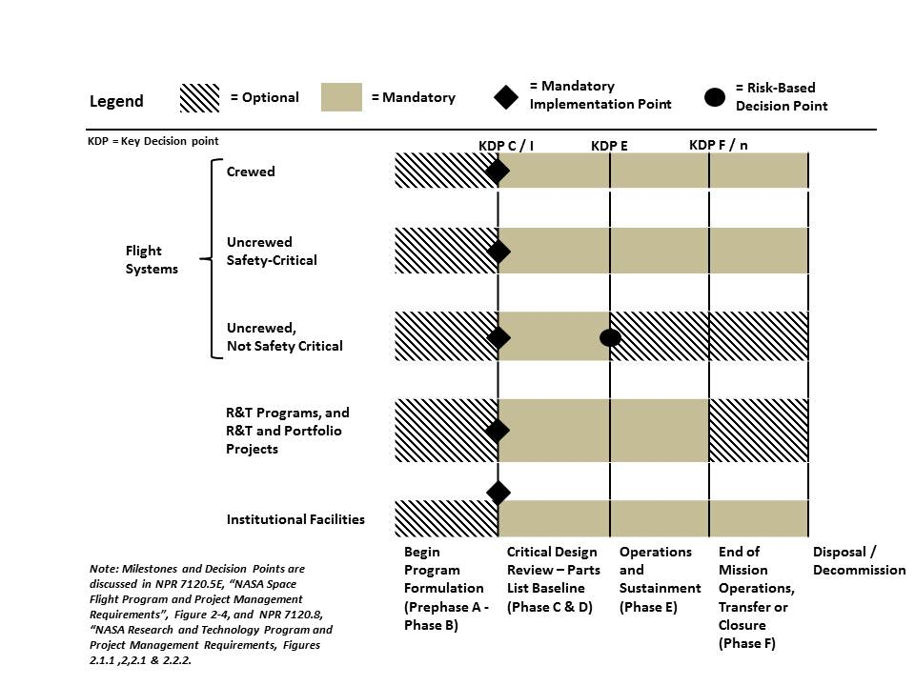

a. For crewed and safety-critical flight systems: Program, Project, and Operations/Institutional Managers shall implement this NPR starting at Key Decision Point (KDP) C (following Preliminary Design Review [PDR]) and continue closed-loop GIDEP reporting until system disposal (Requirement).

b. For uncrewed flight systems that are not safety critical: Program, Project, and Operations/Institutional Managers shall implement this NPR starting at KDP C (following PDR) and continue closed-loop GIDEP reporting until KDP E, when the flight system is declared operational (Requirement).

c. For Research and Technology (R&T) Programs: Program and Operations/Institutional Managers shall implement this NPR starting at KDP I (approval of Program Commitment Agreement [PCA]) and continue closed-loop GIDEP reporting until KDP n (closure) (Requirement).

d. For R&T and Portfolio Projects: Project and Operations/Institutional Managers shall implement this NPR starting at KDP C (approval of project plan) and continue closed-loop GIDEP reporting until KDP F (technology transfer or closure) (Requirement).

e. For institutional infrastructure and facilities: Program, Project, and Operations/Institutional Managers shall implement this NPR starting at KDP C (following PDR) and continue closed-loop GIDEP reporting until the infrastructure/facility is decommissioned (Requirement).

4.2 Upon receipt of a GIDEP Notice or NASA Advisory, all Program, Project, and Operations/Institutional Managers, or designees, shall evaluate and disposition the GIDEP Notice or NASA Advisory by:

a. Determining whether the GIDEP Notice or NASA Advisory affects any products or services procured by NASA directly or through its contractors and their supply chains (Requirement).

b. Determining its relevance and impact to programs, projects, and institutions (Requirement).

c. Identifying actions to be taken to reduce or eliminate any detrimental effects on programs, projects, and institutions or identifying other disposition actions to be taken (e.g., risk accepted after assessment, parts replacement, parts placed in segregated stores, additional testing performed) (Requirement).

Note: Requirements for risk acceptance are given in NPR 8715.3, NASA General Safety Program Requirements; Section 1.6, Risk Assessment and Risk Acceptance.

d. Preparing and releasing closed-loop reports on NF 1544, Problem Impact Statement – Parts, Materials, Software and Safety (see Appendix C) or a Center-designated form (Requirement).

(1) For GIDEP Notices and NASA Advisories that do not apply to, or are not used by, a program, project, or institution: a "no impact" or “no usage” response shall be released on NF 1544 or a Center-designated form (Requirement).

(2) The basis for all responses and dispositions of a GIDEP Notice or NASA Advisory direct impact shall be documented on NF 1544 or Center-designated form (Requirement).

(3) In cases where a GIDEP Notice or NASA Advisory has a direct impact, a risk assessment shall be provided with the Form 1544 or Center-designated form for all use-as-is decisions (Requirement).

e. Collecting additional information as requested by the GIDEP Notice or NASA Advisory initiator (see Appendix F) (Requirement).

4.3 Program, Project, and Operations/Institutional Managers shall ensure that the baselining of parts lists include a check of historical GIDEP Notices and NASA Advisories (see Appendix G) (Requirement).

Chapter 5. Release and Distribution of Data related to GIDEP Notices and NASA Advisories to International Partners
5.1 There are special considerations for the distribution of data derived from a GIDEP Notice or NASA Advisory to one of NASA's international partners. NASA programs/projects that involve an international partner (such as the European Space Agency) might require special review by the Headquarters/Center's Export Control Office prior to distributing to the international partner any data derived from a GIDEP Notice or NASA Advisory.

5.2 For distribution to the international partner, the Center or Headquarters GIDEP and NASA Advisory Coordinator or the Program, Project, or Operations/Institutional Manager shall follow the process shown in Figure 2: Process for releasing GIDEP Notices or NASA Advisory Data to International Partners (Requirement).

Figure 2: Process for releasing GIDEP Notices or
NASA Advisory Data to International Partners
(Note: OIG = Office of the Inspector General)
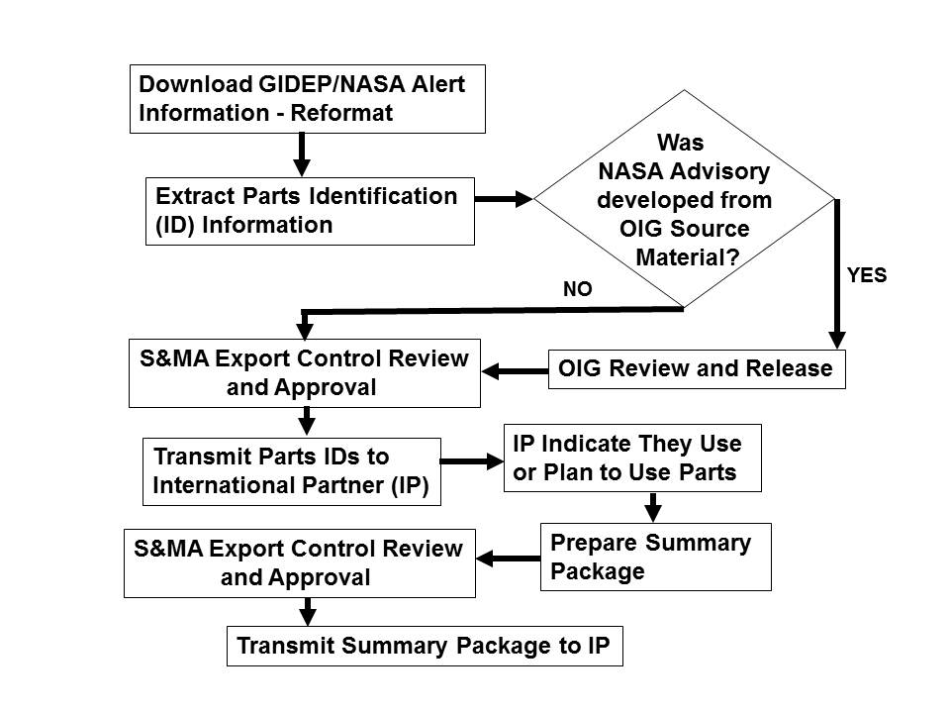
5.3 Center or Headquarters GIDEP and NASA Advisory Coordinator or the Program, Project, or Operations/Institutional Manager shall:

a. Release information excerpted from GIDEP Notices and NASA Advisories in accordance with NPD 2110.1, Foreign Access to NASA Technology Transfer Materials and Appendix F (Requirement).

b. Ensure that only GIDEP Notice and NASA Advisory information that applies to the international partner's participation in a joint NASA/international partner program is released (Requirement).

Note: This means information derived from GIDEP Notices and NASA Advisories that only relates to components or parts utilized in the equipment contributed by the international partner can be released. GIDEP specifically prohibits NASA's distribution of a complete GIDEP document to anyone outside of NASA. All GIDEP documents have a statement at the top which says "Distribution is not authorized outside of the GIDEP participant's organization."
Appendix A. Definitions
Alternate GIDEP and NASA Advisory Coordinator - The Center or Headquarters person appointed by their organization responsible for performing the duties of the GIDEP and NASA Advisory Coordinator in cases when the primary Center or Headquarters Advisory Coordinator is not available. The alternate Center or Headquarters GIDEP and NASA Advisory Coordinator need not be a civil service employee. However, an alternate Center or Headquarters GIDEP and NASA Advisory Coordinator that is not a civil service employee cannot officially represent NASA. An alternate Center or Headquarters GIDEP and NASA Advisory Coordinator that is a civil service employee can officially represent NASA.

CAGE Code - The Commercial and Government Entity (CAGE) Code is a five-position code that identifies contractors doing business with the Federal Government, NATO member nations, and other foreign governments. The CAGE Code is used to support a variety of mechanized systems throughout the government and provides for a standardized method of identifying a given facility at a specific location. The code may be used for a facility clearance, a pre-award survey, automated bidders lists, identification of debarred bidders, fast pay processes, etc.

Vendors and manufacturers providing commercial-off-the-shelf/commercial and nondevelopmental items that are procured by the Government are not required to have an assigned CAGE code.

Closed-loop GIDEP Reporting - Providing a written response of no impact, no usage or impact with rationale at program milestone and readiness reviews or according to contract or other specified reporting times/events for each GIDEP Notice and NASA Advisory on a Parts, Materials, and Safety Problem Impact Statement form [NF 1544 (see Appendix C) or Center-designated form] to the Headquarters and Center GIDEP and NASA Advisory Coordinator.

Corrective Actions - Changes to design processes, work instructions, workmanship practices, training, inspections, tests, procedures, software, specifications, drawings, tools, equipment, facilities, resources, or material that result in preventing, minimizing, or limiting the potential for recurrence.

Functional Failure - A failure resulting in nonfulfillment of required component functions or capabilities.

GIDEP - This acronym stands for "Government-Industry Data Exchange Program." GIDEP is a cooperative information-sharing program between the U.S. Government, Canadian Government, and industry participants. The goal of GIDEP is to ensure that only reliable and conforming parts, materials, and software are in use on all Government programs and operations. GIDEP members share technical information essential to the research, design, development, production, and operational phases of the life cycle of systems, facilities, and equipment.

GIDEP Agency Action Notice - An Agency Action Notice redistributes problem information issued by a Government agency to notify GIDEP participants of problems and actions taken. Distribution of some Agency Action Notices may be limited to Government agencies only, as determined by the submitter. GIDEP Agency Action Notices are submitted on
GIDEP Form 97-3, Agency Action Notice (September 2009) [From SO300-BT-PRO-010, GIDEP Operations Manual (April 2008)].

GIDEP Alert - A standardized report prepared by a GIDEP participant for identification and notification of actual or potential problems on nonconforming parts, components, materials, manufacturing processes, test equipment, construction materials, office equipment, chemicals, or computer software. GIDEP Alerts are submitted on GIDEP Form 97-1, GIDEP Alert (September 2009) [From SO300-BT-PRO-010, GIDEP Operations Manual (April 2008)].

GIDEP and NASA Advisory Coordinator - The primary Center or Headquarters person appointed by their organization to represent them to the GIDEP. The Coordinator is responsible for ensuring appropriate documents generated by their organization are submitted to GIDEP; for coordinating and obtaining user authorization to access the database; and for coordinating and submitting annual utilization reports. The GIDEP and NASA Advisory Coordinator is a NASA GIDEP Representative as defined by GIDEP and by the definition for NASA GIDEP Representative below.

GIDEP Notices - Term used to collectively refer to GIDEP Alerts, GIDEP Safe-Alerts, GIDEP Problem Advisories, and GIDEP Agency Action Notices.

GIDEP Notice or NASA Advisory Direct Impact - A direct impact to a GIDEP Notice or NASA Advisory occurs when the item described in the Notice or Advisory and the item proposed for use, or being used as part of a flight system, ground system, facility, or infrastructure have the same manufacturer and part number, and the lot code is either the same or within the identified lot code range.

GIDEP Problem Advisory - A Problem Advisory reports: (a) preliminary information on a suspected problem, or (b) a problem with parts, components, materials, manufacturing processes, specifications, or test equipment that has a potential for causing a functional failure. Problem Advisories that report preliminary information must be followed by updated reports at not less than 30-day intervals until resolved or canceled. GIDEP Problem Advisories are submitted on GIDEP Form 97-2, GIDEP Problem Advisory (September 2009) [From SO300-BT-PRO-010, GIDEP Operations Manual (April 2008)].

GIDEP Safe-Alert - A Safe-Alert is similar to an Alert, except that it identifies and notifies the GIDEP participant of an unsafe condition. GIDEP Safe-Alerts are submitted on GIDEP Form 97-1, GIDEP Safe-Alert (September 2009) [From SO300-BT-PRO-010, GIDEP Operations Manual (April 2008)].

Ground Support Equipment - Ground-based equipment used to store, transport, handle, test, check out, service, or control aircraft, launch vehicles, spacecraft, or payloads (NASA-STD-8709.22).

NASA Advisory - A NASA document for exchanging significant parts, materials, and safety problems or concerns among NASA activities.

NASA Advisory System - The NASA Advisory System is a community information exchange system and database hosted by, but separate from, the GIDEP system and used to document and store NASA Advisories.

NASA GIDEP Liaison - The NASA Headquarters person that serves as the representative to the GIDEP office in the Department of Defense to communicate with and provide the interfaces between the Agency and the GIDEP. The NASA GIDEP Liaison is a GIDEP Representative as defined by GIDEP.

NASA GIDEP Representative - An individual(s) assigned by NASA who is responsible for the implementation and coordination of GIDEP within the applicable NASA Center. NASA may assign more than one GIDEP Representative when operating groups are not colocated within the same facility or different groups perform different functions.

Nonconformance - The state or situation of not fulfilling a requirement. A nonconforming product, process, software, or material does not meet manufacturing specifications or design, composition, or contractual requirements. Counterfeit parts, products, software, and materials are considered nonconforming and/or nonconformances.

Safety-Critical Item - A part, assembly, installation equipment, launch equipment, ground support equipment, recovery equipment, or support equipment for an aircraft, launch vehicle, space vehicle or facility if the part, equipment, or assembly contains a characteristic whose failure, malfunction, or absence could cause a catastrophic or safety-critical failure resulting in the loss of or serious damage to the craft/vehicle/facility, loss of mission, an unacceptable risk of personal injury, or loss of life.

Significant Problem - Any problem that is of the highest category of significance by virtue of the problem's impact on personnel safety or mission accomplishment (schedule and objectives).

Appendix B. Guidelines for Contractual Implementation of GIDEP

B.1 Per paragraph 1.2.4 c of this NPR, Program, Project, and Operations/Institutional Managers are responsible for incorporating requirements for contractor participation in GIDEP and the NASA Advisory System in contract statements of work or specifications.

B.2 The following factors should be considered in this determination:

a. Type of Procurement - consider the commodity (items, parts, and materials) being purchased.

b. Acquisition Phase - consider the phase of the program and the utility of the GIDEP Notice* and NASA Advisory data to support that phase; generally, activities after the conceptual design phase can benefit most from participation.

c. Dollar Value of Contract - consider the amount of the contract and the benefit to be obtained from participation or the risks of not participating. There is no membership fee to contractors for participating in GIDEP. There are resources required to review and evaluate GIDEP Notice and NASA Advisory information. Participation in GIDEP should be included in all procurements for supplies that exceed $500,000 and should be considered for all procurements for services that exceed $500,000.

d. Criticality of the Equipment - consider the potential for loss of or damage to the equipment or personnel if GIDEP Notice and NASA Advisory information is not utilized. The primary focus of having contracts for participation in GIDEP is to ensure that GIDEP Notice and NASA Advisory data are available and utilized during research, design, development, production, and operational phases of the life cycle for systems, facilities, and equipment. Participation in GIDEP should be included for all procurements for safety-critical items as defined in Appendix A.

e. The following is a suggested GIDEP/NASA Advisory Participation Statement of Work. This text may be tailored at the Center's discretion.

"The Contractor shall participate in the Government-Industry Data Exchange Program (GIDEP) in accordance with the requirements of the GIDEP Operations Manual (GIDEP SO300-BT-PRO-010) and the GIDEP Requirements Guide (SO300-BU-GYD-010), available from the GIDEP Operations Center, PO Box 8000, Corona, California 92878-8000. The Contractor shall review all GIDEP Notices* and designated NASA Advisories to determine if they affect the Contractor's products/and or services provided to the Government. The Contractor shall respond by stating, in writing, whether or not each GIDEP Notice and NASA Advisory affects the Contractor's products and services provided to the Government. The contractor is responsible for stating whether or not each GIDEP Notice and NASA Advisories affects the subcontractor's products and services provided to the Government. For GIDEP Notices and NASA Advisories that affect the Contractor's products and services provided to the Government, the Contractor shall take action to eliminate or mitigate any negative effect and inform the Government of such actions to ensure GIDEP Notices and NASA Advisories adhere to close-loop reporting**. The Contractor shall generate applicable GIDEP Alerts in accordance with the requirements of GIDEP SO300-BT-PRO-010 and SO300-BU-GYD-010 whenever failed or nonconforming items, available to other buyers, are discovered during the course of the Contract."

"* The term "GIDEP Notices" means "GIDEP Alerts, GIDEP Safe-Alerts, GIDEP Problem Advisories, and GIDEP Agency Action Notices." Life-cycle logistics should be addressed per contractual requirements identified by the Program/Project."

"** The term "close-loop reporting" means providing a written response of no impact, no usage or impact with rationale at program milestone and readiness reviews or according to contract or other specified reporting times/events for each GIDEP Notice and NASA Advisory."

"If suspect/counterfeit parts are furnished under this agreement and are found on the (site), such items shall be impounded by (site). The Seller shall promptly replace such items with items acceptable to the (site) and the Seller shall be liable for all costs relating to impoundment, removal, and replacement. (Site) may turn such items over to NASA Office of Inspector General, FBI, etc., for investigation and reserves the right to withhold payment for the suspect counterfeit items pending the results of the investigation."

f. Contractors shall provide GIDEP Notice and NASA Advisory disposition documentation to NASA up to the time that process closed-loop reporting is no longer required. The GIDEP and NASA Advisory Coordinator is responsible for ensuring records management and retention, as set forth by Federal records procedures and guidelines of NPR 1441.1, NASA Records Retention Schedules, in coordination with the Agency or Center Records Officer. GIDEP Notice and NASA Advisory data and records are part of the Agency Filing Scheme Program Management category with an 8700 Primary Identification Codes Series for Safety and Mission Assurance.

g. The contractor is responsible for the flow-down of these requirements to subcontractors and subcontractor adherence to closed-loop reporting. Therefore, the Contractor agrees to insert the preceding paragraphs in any subcontract for supplies hereunder exceeding $500,000 or supplying safety-critical item(s) as identified by the Contract. When inserted, the words, "Contractor" should be changed to "Subcontractor," and "Government" should be changed to "Customer."

h. Information and materials concerning GIDEP are available from:

GIDEP Operations Center
P.O. Box 8000 Corona, CA 92878-8000
Phone: (951) 898-3207
Fax: (951) 898-3250
Website: www.gidep.org
Appendix C. NF 1544, Problem Impact Statement - Parts, Materials, Software and Safety
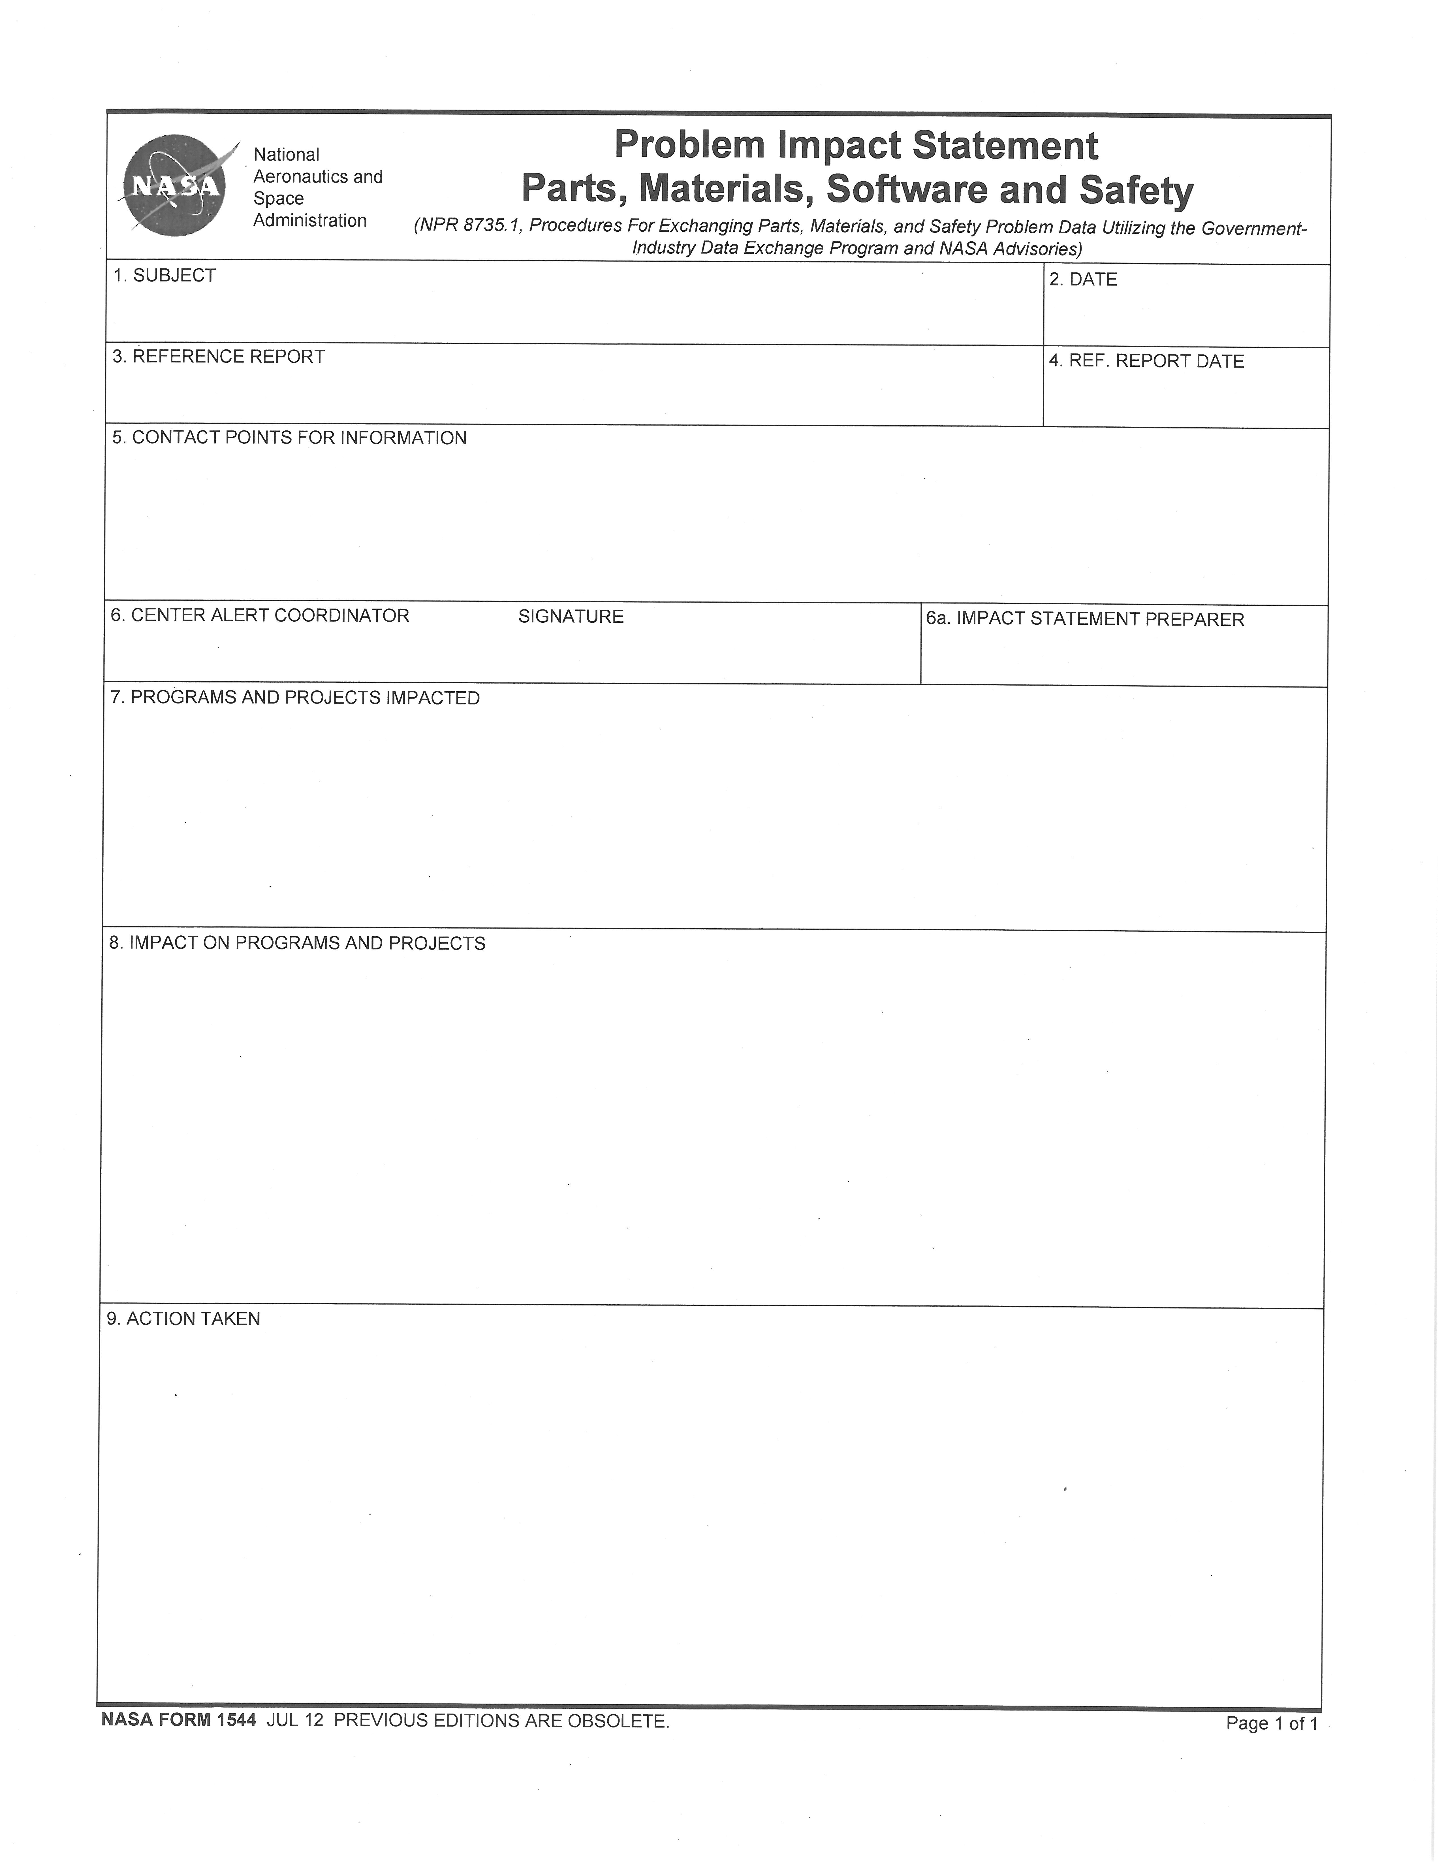
Appendix D. Problem Data Exchange Process

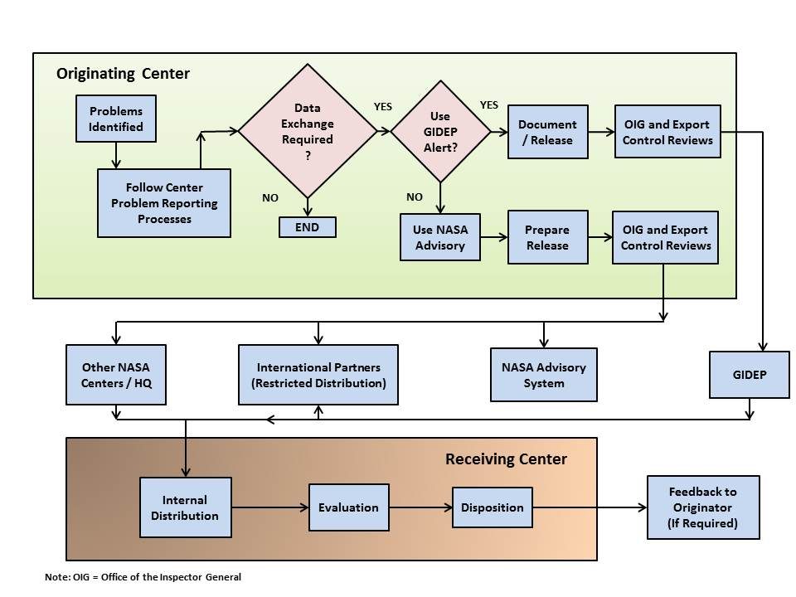
Appendix E. Template for a Center GIDEP Implementation Document

1.0 Purpose or Objective

2.0 Scope & Applicability

Scope:
Applicability:

3.0 Authority

4.0 Responsibilities

Center Management
Programs/Projects/Institutions
Center GIDEP and NASA Advisory Coordinator
GIDEP Response Acceptance

Contractors

5.0 Center GIDEP Implementation Procedures

NASA GIDEP Requirements

GIDEP Reviews, Support, Dissemination and Reporting
Disposition of GIDEP Notices/NASA Advisories
Issuing GIDEP Notices/NASA Advisories

Contractor GIDEP Requirements

GIDEP Reviews, Support, Dissemination, and Reporting
Disposition of GIDEP Notices/NASA Advisories
Issuing GIDEP Notices/NASA Advisories

6.0 GIDEP Training

7.0 Management Records & Records Retention

8.0 Relevant Documents

9.0 Definitions

10.0 Acronyms
Appendix F. Additional GIDEP Information

F.1 NASA Advisories that deal with fraud, waste, or abuse will generally require additional information on NF 1544 to assist the NASA Office of the Inspector General in the preparation of any legal casework and to assist in cost-recovery action.

F.2 Such additional information may include:

a. Programs, Projects, and Institutions Impacted (Block 7): In addition to the list of programs/projects affected, the costs incurred in investigation of the impact to the programs/projects should be indicated. If there is no impact, the costs incurred to make that determination should be indicated.

b. Impact on Programs, Projects, and Institutions (Block 8): In addition to the required impact summary, the number of parts involved and their estimated cost should be indicated (e.g., 10 lots of fasteners totaling 135 fasteners with an estimated cost of $10,000).

c. Action Taken (Block 9): In addition to the summary of actions taken to eliminate or minimize the impact, any additional testing or inspection should be indicated. The results of those inspections or tests should be provided (e.g., Particle Impact Noise Detection test performed on 40 items with three failures). If a scrap decision is made, the number of items scrapped and their value should be indicated.
Appendix G. Auto-Match Searches
G.1 GIDEP is continuing the development of a parts batch search routine that permits GIDEP participants to send parts lists to GIDEP where they are stored and compared to the part identifiers in the GIDEP database. (Part lists are protected so that only Operations Center personnel will have access.)

G.2 CURRENT FEATURES

- Part Identifier comparison (Manufacturer, Government, Specification, Drawing, Model, Base, and National Stock Number (NSN))
- Results based on "Exact" match search
- Specify data types of interest (e.g., failure experience data, Alerts, reliability, etc.)
- Part input stored at Operations Center for re-runs and modifications/updates
- Auto-batching (nightly-by request only) as new documents are loaded
- Results via e-mail

G.3 FUTURE CAPABILITIES

- "Fuzzy" search returns parts similar to input
- User interface through the World Wide Web

G.4 HOW TO BATCH

The Batch program operates on an "Exact" match and returns only those results. Correct formatting is crucial to obtaining correct results and any listings which require reformatting by the Operations Center may result in errors or duplicate notification.

To eliminate missing results, your attached list should be formatted as follows:

1. Part identifiers in single column American Standard Code for Information Interchange (ASCII) text (no limit) (Part identifiers include Manufacturer part, Government, Specification, Drawing, Model, Base, and NSN)
2. Do NOT remove any dashes, slashes, or other characters contained in the part identifiers
3. Full NSN (no National Item Identification Numbers (NIINs)) must contain dashes (i.e., 5962-01-111-8890)
4. Remove extraneous information such as size, color, or identifier information

In your e-mail message body, include the following:

- Your Name
- Company Name
- GIDEP Participant Code
- Program(s) related to the part list (optional)
- Data types of interest (e.g., DMS, Metrology, Alerts, etc.)
- Your e-mail address for results

E-mail the above to GIDEP Operations Center via batch@gidep.org
Contact: Bill Pumford - (951) 898-3207

